**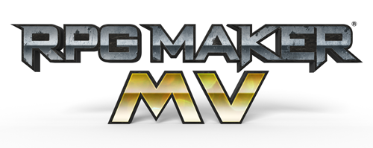  
RPG Maker MV Help**

Explanations regarding functions included in RPG Maker MV can be found in this Help section.  
The Help Table of Contents can be found on the left side of this window. Please choose which item you wish to view from here.

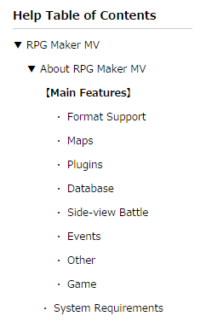

Additionally, pop-up hints are also available when using this software for most items. By hovering your cursor over an item for a brief time in the editor, a simple explanation will be displayed, so please feel free to take advantage of this as well.

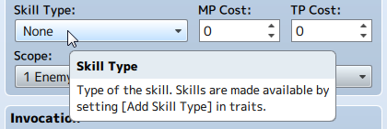

# About RPG Maker MV

* About RPG Maker MV

RPG Maker MV is a specialized creation tool for making role playing games.  
Games created using this software can also be played by users who do not have access to this tool.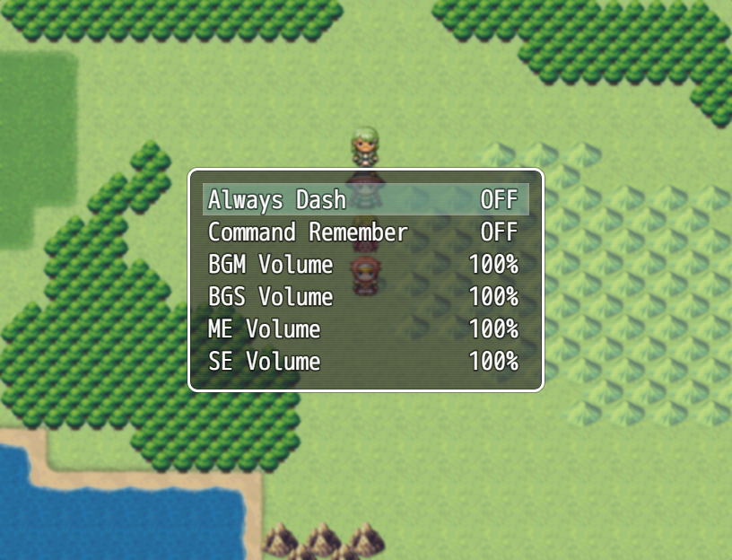 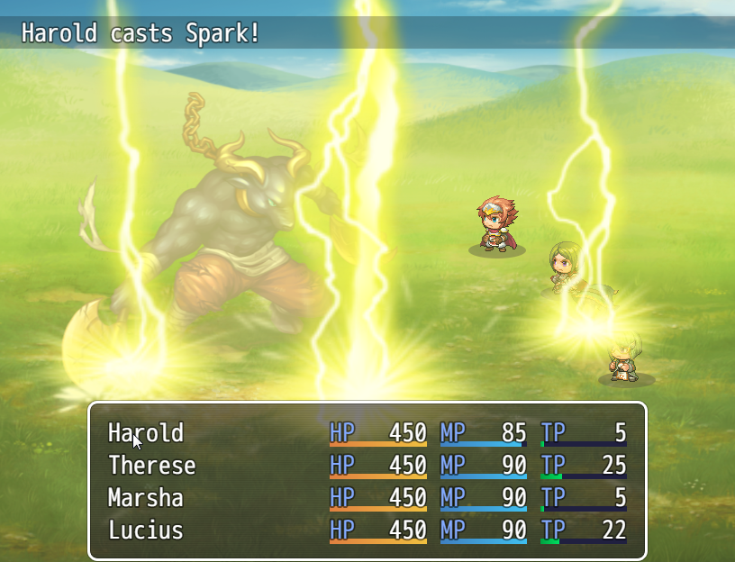

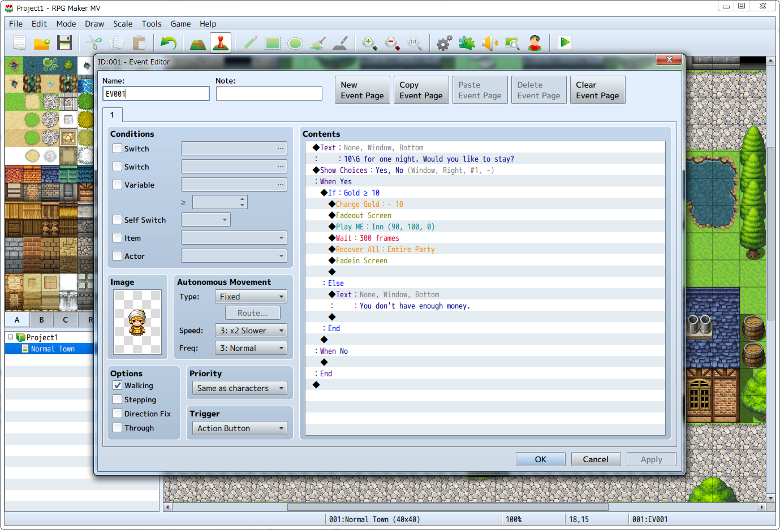

# Format Support

# The RPG Maker MV Mac Version that Mac users have long been waiting for has finally been released! The ease of use found in the Windows version has been maintained, making it possible for Mac users to create games using a deep and familiar interface.

# https://rmmv.neocities.org/inc/img/01_01_01_01_img01.png

## Multiplatform Support

Games are now in HTML5 format, allowing not only for distribution to various environments such as Windows, Mac OS X, Android, and iOS, but it is now also possible to release games as-is online.  
Please view [[Output Formats](https://rmmv.neocities.org/page/01_11_04.html)] for more information.

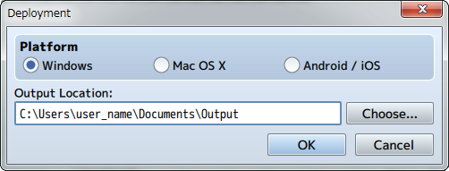

# Maps

The map represents the world in which the game will take place. In RPG Maker MV, the map creation feature has been enhanced, allowing users to create a more diverse world.

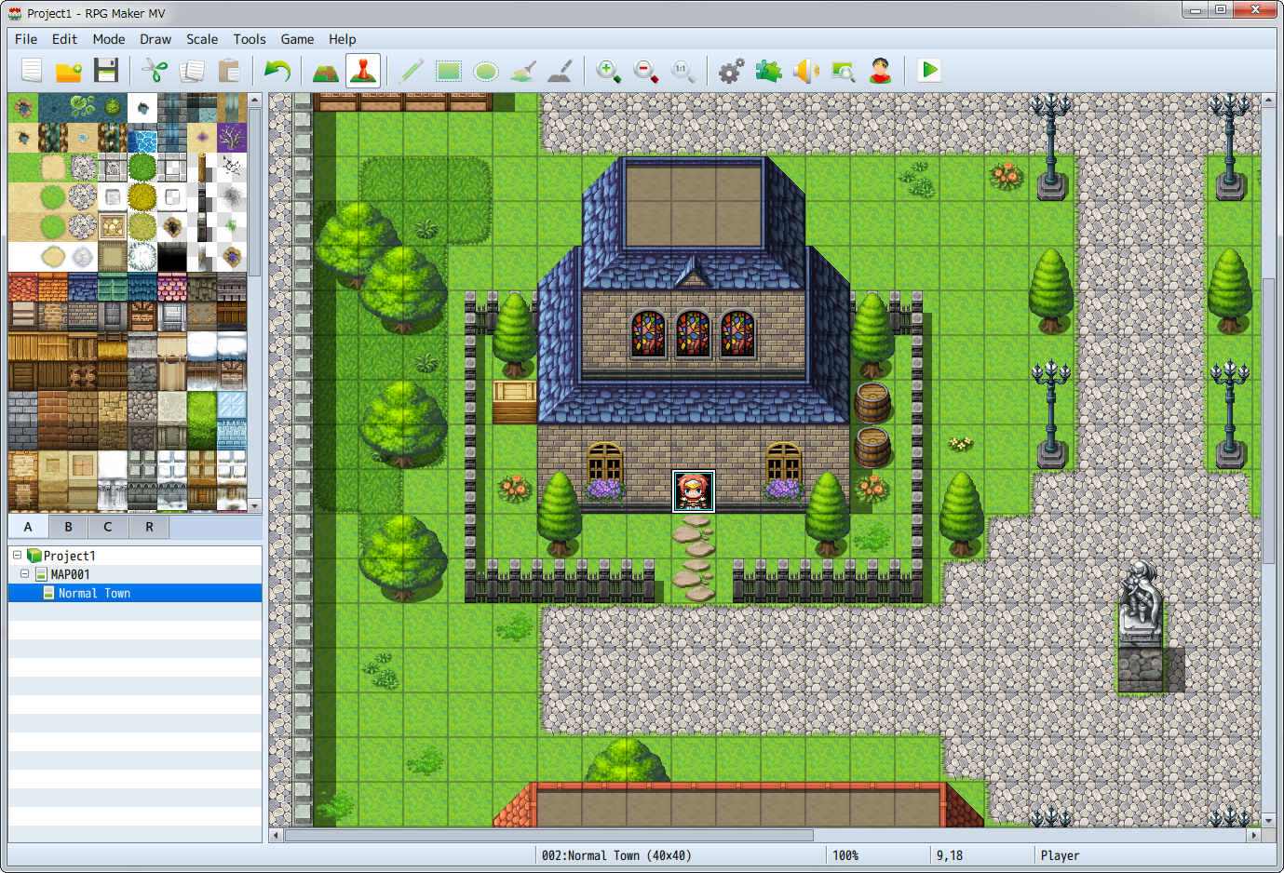

## Main Features

### Now possible to create an even richer world.

* Game resolution has been increased from 544x416 to 816x624.
* The upper two tiles can now be automatically overlapped.
* 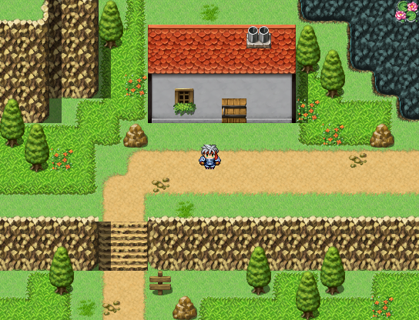  
  RPG Maker VX Ace

* 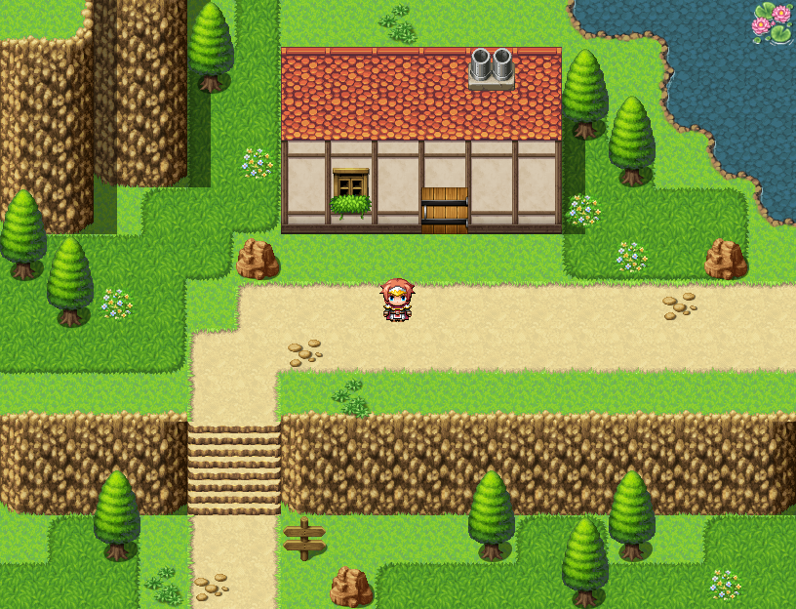  
  RPG Maker MV

### Enhanced Region Features

Users can now switch to Region Editor Mode using the Tile Palette tab. The maximum number of tiles has been changed from 63 to 255. It is now possible to edit regions in more detail.

### Save Maps as Images

It is possible to save the maps you create as images by selecting［Save as Image］from the context menu in the map list.

# Plugins

The traditional Script Editor has been removed, and easy to use plugin functions have been adopted.  
There are official plugins included in the plugins, and these can be used right from the start.  
* Please refer to [[Enabling Plugins](https://rmmv.neocities.org/page/01_11_09.html)] and [[Using Official Plugins](https://rmmv.neocities.org/page/01_11_10.html)] for more information.

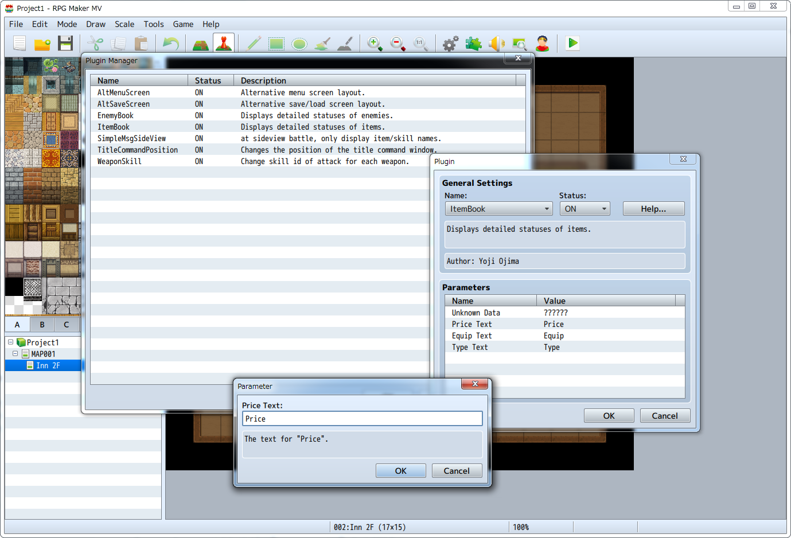

* Additionally, refer to [[Plugin Specifications](https://rmmv.neocities.org/page/01_11_03.html)] regarding plugin specifications.

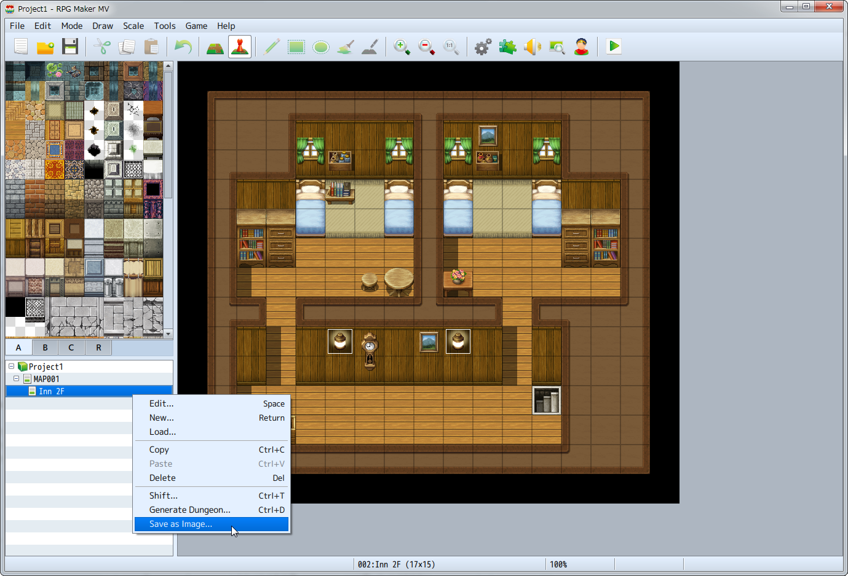

# Database

The various data which are available in the game such as characters, items, skills and magic are edited and managed using the database.

## Main Features

**Increased Database Volume**

The maximum number of database entries has been changed.  
It is now possible to configure up to 2000 skills, items, weapons, armors, enemy characters and enemy groups.  
(And a maximum of an additional 1000 entries)

**More robust and easy to use features**

* Now possible to select and copy multiple items using the List Box.

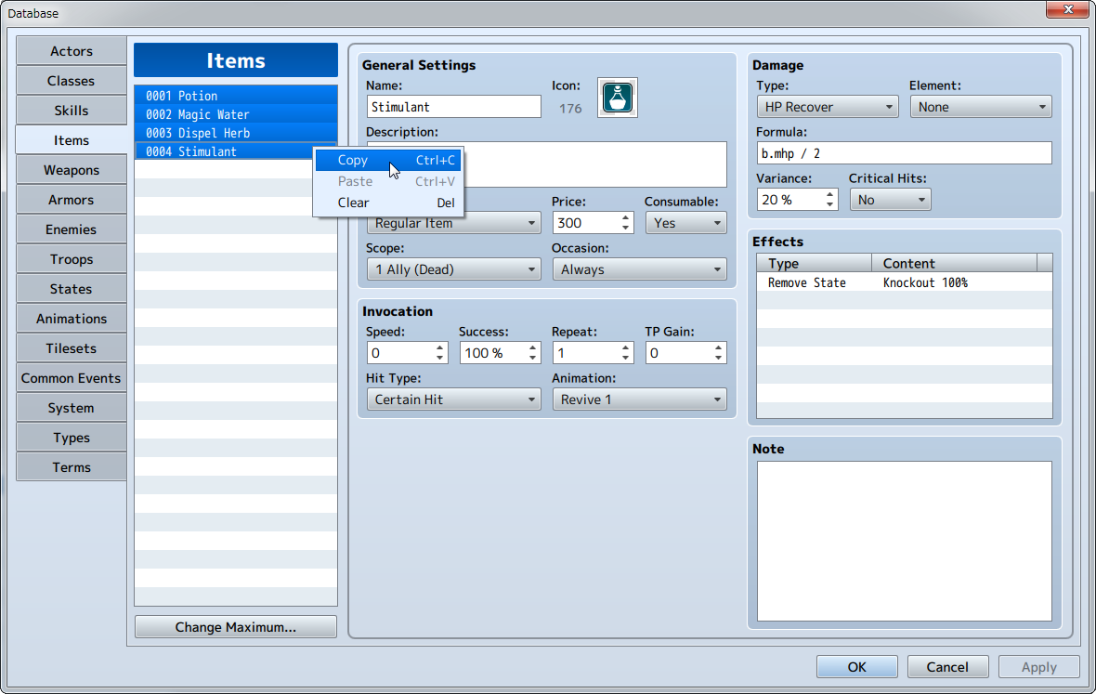

* Messages which were traditionally changed via scripts can now be managed and changed in the [Terms] tab.

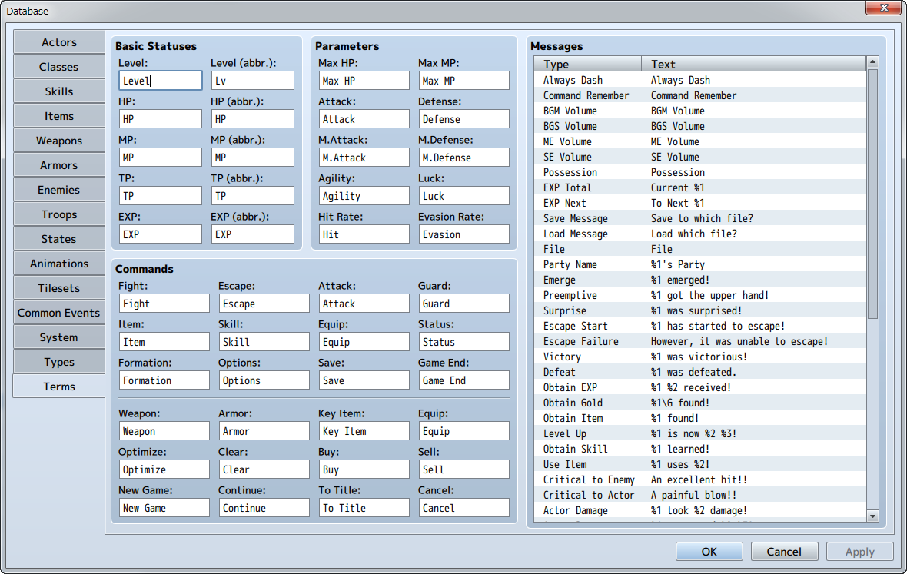

* Equipment types (arm equipment, leg equipment, etc.) can be increased and decreased from [Types].

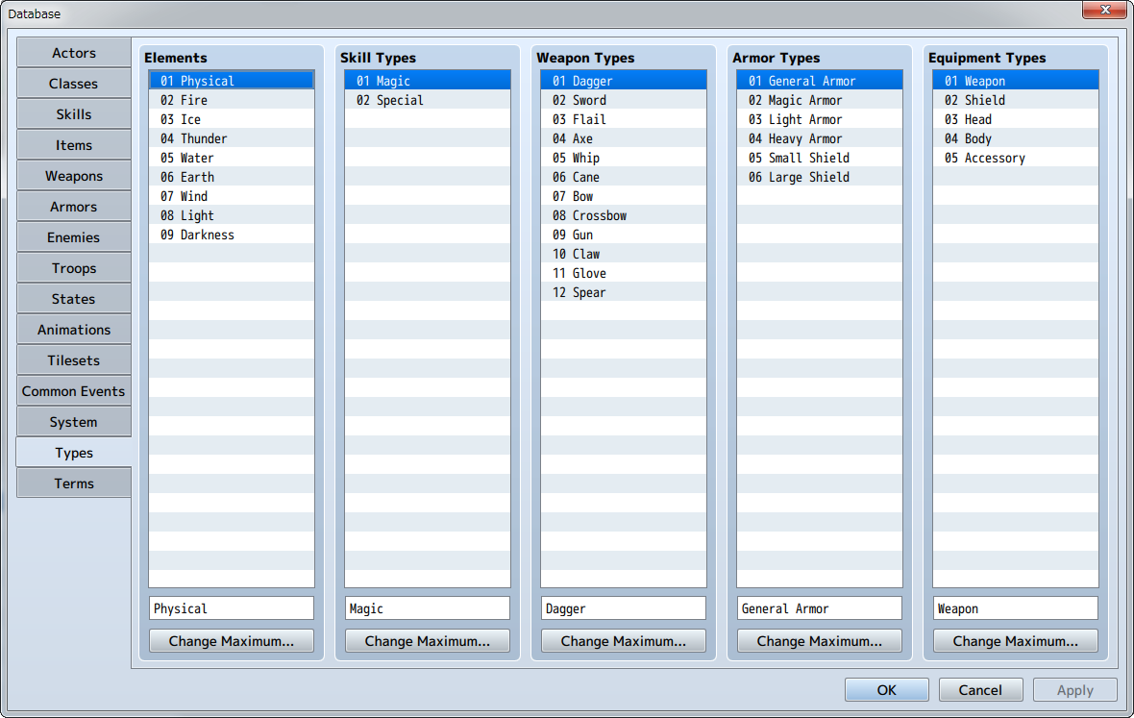

* Commands displayed in the in-game menu can have their visibility managed in the [System] tab.
* [Hidden Items A, B] under [Item Type] are now selectable in the [Items] tab

# Side-view Battle

In addition to the Front-View Battle available in the previous version, a new Side-view Battle is now available.



## Configuration Items for Side-view Mode

Now that Side-view Battle is now possible, actors are now displayed in the Battle Screen, and elements which can be set such as images and motions have been added.

**System: Use Side-view Battle**

When setting this to ON, in-game battles will now be in Side-view Mode.  
Please view Database: [[System Settings](https://rmmv.neocities.org/page/01_08_12.html)] for more information.

**System: Magic Skills**

Configures Skill Types which require chanting motions.  
Please view Database: [[System Settings](https://rmmv.neocities.org/page/01_08_12.html)] for more information.

**System: Attack Motions**

Sets an animation for each type when attacking.  
Please view Database: [[System Settings](https://rmmv.neocities.org/page/01_08_12.html)] for more information.

**Actor: Battler**

Set the image of actors displayed during battle.  
Please view Database: [[Actor Settings](https://rmmv.neocities.org/page/01_08_01.html)] for more information.

**State: Motion**

Sets animations displayed according to state of actor.  
Please view Database: [[State Settings](https://rmmv.neocities.org/page/01_08_08.html)] for more information.

**State: Overlay**

Sets the image that is displayed over the actor's image according to the actor's state.  
Please view Database: [[State Settings](https://rmmv.neocities.org/page/01_08_08.html)] for more information.

# Events

Events happen in situations such as when having conversations with characters and obtaining items from treasure chests.

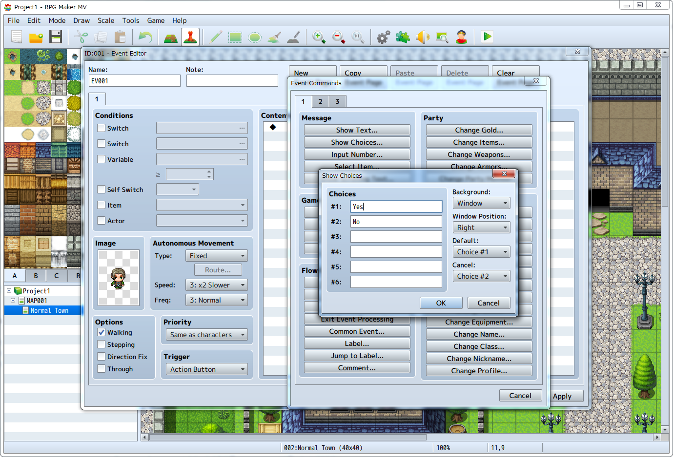

## Main Features

**Event Test Features**

Checking the display of pictures, movement and rotation is possible without using Playtest.

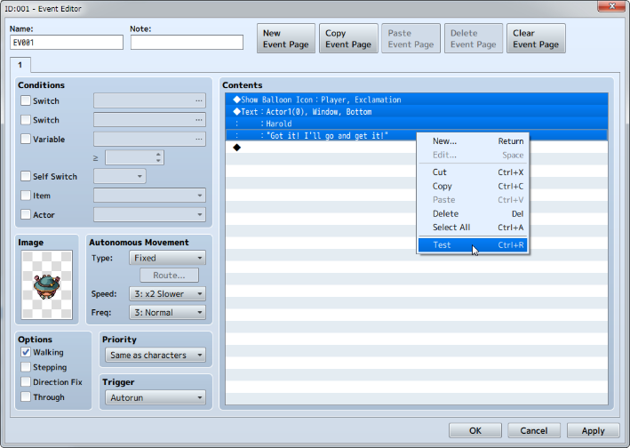 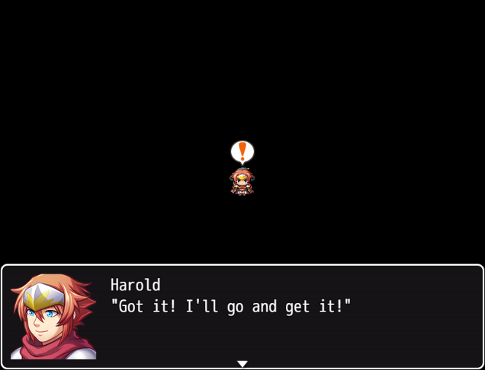

**Additional Event Commands**

It is now possible to configure the below new items.

* Actor: [Change Profile]
* Actor: [Change TP]
* System Settings: [Change Vehicle BGM]
* System Settings: [Change Defeat ME]
* Battle: [Change Enemy TP]
* Advanced: [Plugin Commands]

**Event Command Revisions**

* The limit of choices has been raised from 4 to 6, and it is now possible to indicate the initial position and transparency of windows.

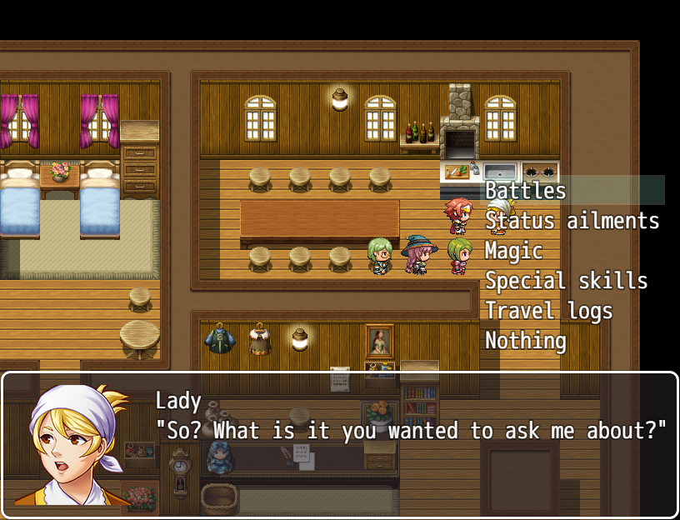

# Other

## Event Searcher

An Event Searcher feature has been added.  
Please refer to [[How to use Aid Tools](https://rmmv.neocities.org/page/01_05.html#p03)] for more information.

## Pitch Added to Audio Settings

Pitch has been added to the Audio Settings for BGM (background music), BGS (background sound) and SE (sound effects).  
It is now possible to adjust the left and right balance of speakers.

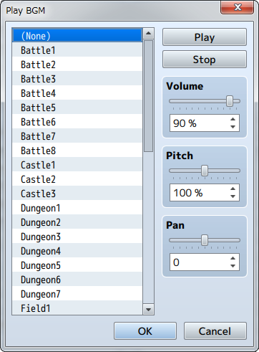

# Game

Game features made using RPG Maker MV have also been improved.

## Main Features

* It is now possible to change the game window size by dragging.
* You can now rapidly go through and speed up events by holding down the action key.
* The [Option] command has been added to the menu screen.



* The tempo for battles has been sped up compared to previous versions.
* The image of the target that an action will be performed on during battle will now flash.
* Damage values in battle will now pop up.

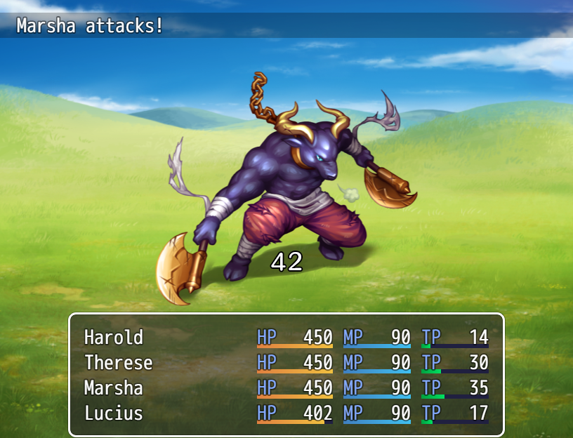

* State icons will now be displayed above enemies.

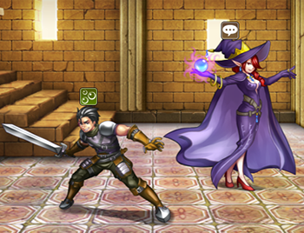

* Previously used skills will now be saved during movement and in battle.
* Music will continue playing without stopping when switching to the battle screen if the map and battle background music is the same.
* The game's title will now be stored in the save file. This will be used to differentiate games when uploading in order to use the same save domain on server.
* The maximum number of save files has been increased from 16 to 20.
* You can now change fonts by editing the CSS (/fonts/gamefont.css) file inside the game folder.  
  * To change font, copy the font file in the same folder.

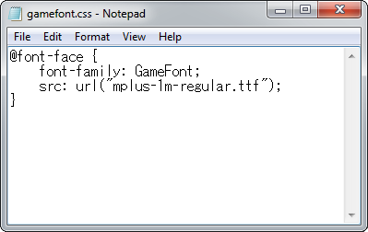

* It is now possible to run Developer Tools by pressing the F8 key while test playing your game.  
  Please refer to [[How to Use Developer Tools](https://rmmv.neocities.org/page/01_05.html#p04_01)] for more information.

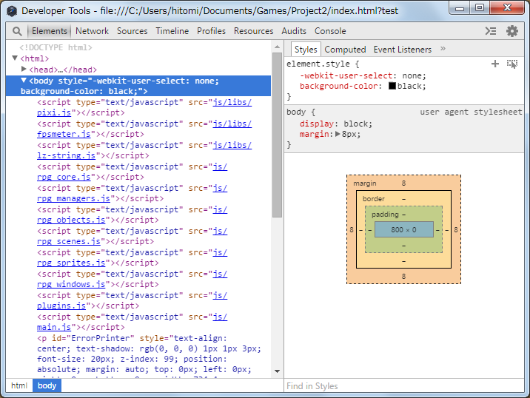

* You can play the game in your browser by uploading the project folder on a web server.  
  Please refer to [[Gameplay System Requirements](https://rmmv.neocities.org/page/01_11_04.html#p01_01)] for more information.

# System Requirements

The system requirements for this software are as follows.

|  |  |
| --- | --- |
| OS | Windows 7/8/8.1/10 (32bit/64bit) or Mac OS X 10.10 or higher |
| CPU | Intel Core 2 Duo or equivalent or greater |
| RAM | 2GB or more |
| HDD | 2GB or more of free disk space |
| Graphics Card | One with OpenGL support |
| Display | Resolution of 1280×768 or greater |

* Internet connection is required to perform the network authentication.
* Specifications required to play the game smoothly vary based on the content of the game.

# Getting Started Making Your Game

## Creating a Project

In order to start making your game, you first need to create a "Project". A project contains all the data and assets which compose a game. You can also import your own files such as images and music and use them in your project.  
  
The way to create a project is as follows.

**(1) Creating a New Project**

Click the [New Project] button on the toolbar or select [New Project] option found under [File] in the menu bar.

**(2) Entering a save location and title**

Enter the project name (half-width alphanumeric characters are recommended), and enter the name of your game under [Game Title]. The project’s save location will be displayed under [Location]. To change the save location, click the [Choose... ] button to the right and specify a new save location.

After setting the above and clicking [OK], a sample game will be created using the settings, and you will be able to start making your game.

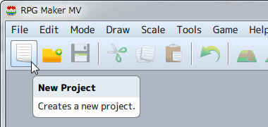 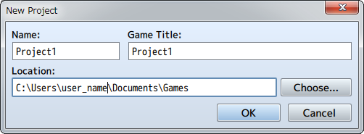

## Managing Projects

**Saving/Loading a Project**

When taking a break from making your game, make sure to save the project and close the program. When you click the [Save Project] button (or go to [Save Project] under [File]), the contents of the project you are currently editing will be overwritten and the project will be saved.  
  
To resume making your game, click the [Open Project] button (or go to [Open Project] under [File]), and select the [Game] file (or [Game.rpgproject]) and click [Open].

**Backup/Deletion**

The contents of a project will be saved to the folder that you chose when creating a new project. Copy the entire contents of this folder and save on a flash drive or other device to backup your project. When you no longer need a project, delete the folder as you normally would.

## Moving on to Creating Your Game

RPG games, the type of game made using this software, are made up of various components such as images on the Play Screen, the characters that players can control, item and magic settings, attacks and the story.  
  
In this software, these elements are made using the three types of data which are at the core of your game: the [Map], which is the setting for your game, [Events] which represent what occurs in the game and the [Database] which determines the settings for things such as characters.  
  
There is no particular order to creating a game. If this is your first time making a game using this software, it is recommended that you start from learning how to make a map. Following which you can then prepare the events and characters to fit the contents of the game you want to make.

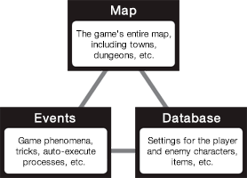

# Basic Editor Controls

## Names and Functions of Each Window Component

The screen which appears after opening a project is called the "Main Window". The Main Window is primarily used to edit the map and events. Tools such as the [Database] are opened from the Main Window menu. The functions of each component are as follows.

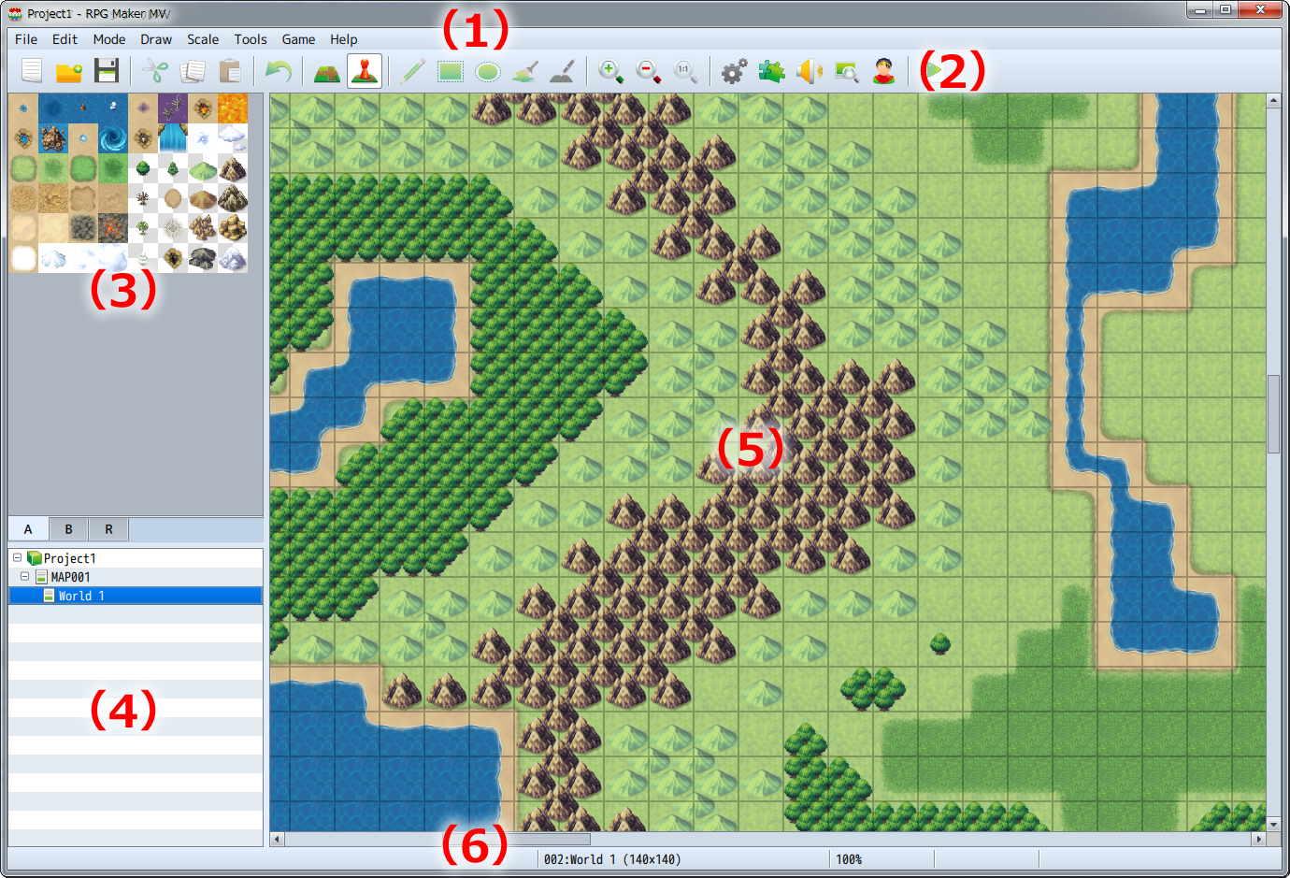

**(1) Menu Bar**

Functions available in this software are selected from here.

**(2) Toolbar**

The specified function can be run from clicking its button.

**(3) Tile Palette**

Tilesets which can be placed on the map are displayed here. You can switch to Set/Region Editor Mode using the tabs below.

**(4) Map List**

A list which shows Map data included in the game currently being created.

**(5) Map View**

Displays the contents of the map that is currently selected. It is used for things such as editing designs and specifying placement of events.

**(6) Status Bar**

Displays details of the function that is currently selected, the map name and map coordinates.

## Editing Parameters

Adjusting the parameters available in the various windows of the things you want to make, and specifying things such as text and items is at the core of the creation process when creating games using this software. The different types of items you can set and how to edit them are as follows.

**Input Text**

When you click on the settings field, the "|" cursor is displayed. Input text using the keyboard in this state. Text will appear at the location of the cursor. You can also move the cursor using the cursor key on the keyboard. The method for entering text differs depending on the input software (IME) you are using.

**Input Values**

Just as with entering text, when clicking on the parameter field, the "|" cursor is displayed. Input values using half-width characters using the keyboard in this state. By clicking on the [∧] and [∨] buttons located to the right of the settings field, you can increase or decrease the values.

**Radio Buttons**

Select one item from a list of multiple items. By clicking the [○], the item which contains the black dot is enabled.

**Check Boxes**

Enables/disables the parameter displayed next to the parameter name. By checking the [□], that parameter becomes enabled. Clicking once again removes the checkmark.

**Pull-down List**

Make a selection from items displayed in a list. Clicking the [∨] arrow located to the right of the settings field opens the list.

**List Box**

Display multiple settings in a list. You can add details and make changes in the window by double-clicking an item.

**[...] Button**

Details of items which have a [...] located to the right of a settings field are specified in a separate window. Click the [...] and set your parameters in the window that is displayed.

**[OK] [Cancel] [Apply] Buttons**

By confirming the details of the settings which you have changed, they will become effective. Clicking [OK] finalizes these settings and closes the window. Clicking [Cancel] discards all changes to items and closes the window and clicking [Apply] confirms settings without closing the window.

# The Menu Bar



Details regarding the items found in the Menu Bar in the Main Window are as follows.

### [File] Menu

**New Project**

Creates a new project. If a project is already opened, it will be closed upon creating a new project.

**Open Project**

Opens a saved project, allowing you to edit your game. Select your [Game] (or [Game.rpgproject]) file by selecting it inside its project folder using the [Open] window.

**Close Project**

Closes the currently opened project. A confirmation window will appear if there is data which has not been saved. Click [Yes] to close the project after saving and click [No] to close the project without saving.

**Save Project**

Overwrites the contents of the project you are currently editing.

**Deployment**

Builds your project in the platform format selected. For more information, please view [[Output Formats](https://rmmv.neocities.org/page/01_11_04.html)].

**Exit RPG Maker MV**

Closes the program. Just like [Close Project], a confirmation window will appear if there is any unsaved data.

### [Edit] Menu

**Undo**

Allows you to undo the action that you just performed and return the project to its previous state as it was 1 step prior. You can undo up to 20 actions.

**Cut**

Deletes data which you have selected such as map data and map events and copies it to the clipboard.

**Copy**

Copies data such as map data and map events to the clipboard.

**Paste**

Adds the contents of the clipboard as new map data and map events.

**Delete**

Deletes data such as the map data and map events you have selected.

### [Mode] Menu

**Map**

Switches to the Map Design Editor Mode.

**Event**

Switches to the mode that allows you to create and edit map events. Lines which are determined by the size of tiles are displayed in the Map View.  
* Select the [R] tab in the Tileset to enter the Region Editor Mode where you can define the region where enemy groups will appear (areas where you encounter enemies).

### [Draw] Menu

A tool for drawing on tiles is available in the Map Editing Mode. Please refer to [[Editing Map Designs](https://rmmv.neocities.org/page/01_07_01.html)] for more information.

### [Scale] Menu

**Zoom In**

The Map View will get bigger each time you select Zoom In.

**Zoom Out**

The Map View will get smaller each time you select Zoom Out.

**Actual Size**

Displays map in standard size (displays at same magnification).

### [Tool] Menu

**Database**

Opens the settings window for the [Database] where you can create/edit elements such as your characters and items.

**Plugin Manager**

You manage your plugins here. For more information, please view [[How to use Aid Tools](https://rmmv.neocities.org/page/01_05.html#p01)].

**Sound Test**

You can play test sounds loaded as asset files in your project. For more information, please view [[How to use Aid Tools](https://rmmv.neocities.org/page/01_05.html#p02)].

**Event Searcher**

You can search for events using various conditions. For more information, please view [[How to use Aid Tools](https://rmmv.neocities.org/page/01_05.html#p03)].

**Character Generator**

Combine pre-made parts to make face graphics, walk characters, and battlers. For more information, please view [[How to Use Aid Tools](https://rmmv.neocities.org/page/01_05.html#p05)].

### [Game] Menu

**Playtest**

Starts a Playtest of your game. For more information, please view [[How to use Aid Tools](https://rmmv.neocities.org/page/01_05.html#p04)].

**Open Folder**

Opens the folder where your project is saved. Use this when you want to check the location of your project folder or when you want to manually move files in your project folder.

### [Help] Menu

**Contents**

Displays the Help window (this window).

**About**

Shows version information about this software.

# How to Use Aid Tools

## Plugin Manager

With the [Plugin Manager] tool that you can open by going to [Tools] → [Plugin Manager], you can manage official plugins and ones that you have created.

When you click on a plugin displayed in the list, a dialog window will appear where you can change their ON/OFF switches and parameter values.

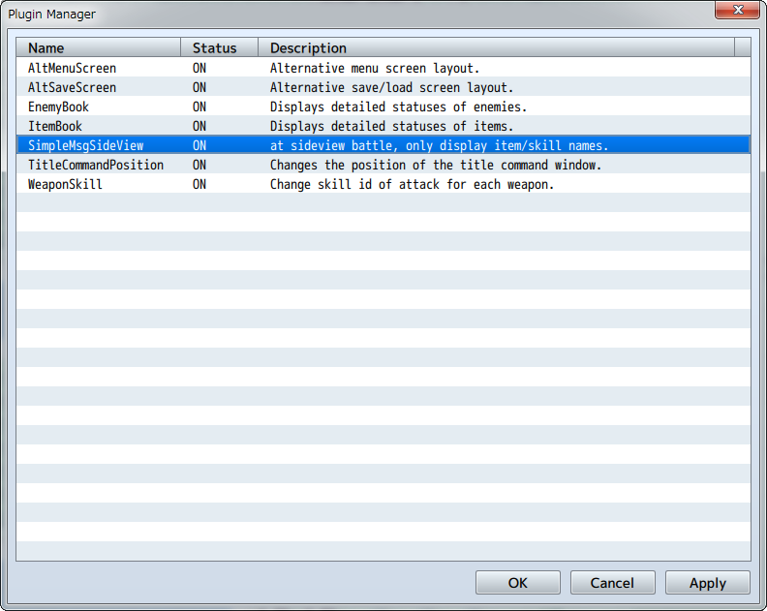 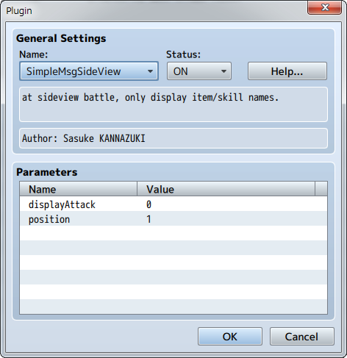

## Sound Test

With the [Sound Test] tool that you can open by going to [Tools] → [Sound Test], you can test the sound of music and sound files which are included in your project. Music will continue playing even after you close the window so you can use it to play background music as you are making your game.  
  
The window is divided into 4 tabs: BGM (background music), BGS (background sound), ME (music effects) and SE (sound effects). You can assign music by clicking on the song in the File List of each tab. When you press [Play] the music will begin to play. Click [Stop] to stop the music.  
  
You can adjust the Playback Volume (0 to 100%), Pitch (50 to 150%) and Pan (-100 to 100) by using their respective sliders.

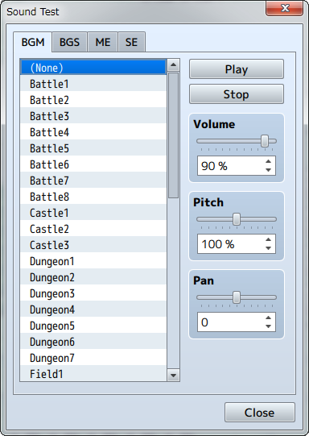

## Event Searcher

With the [Event Searcher] tool which can be opened by going to [Tools] → [Event Searcher], you can search events by their switches, variables and names and display them in a list.

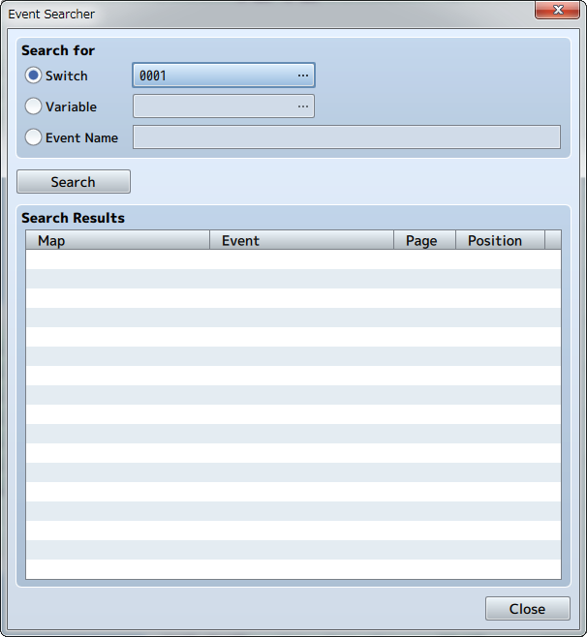

## Character Generator

Open this tool by clicking on [Tools] → [Character Generator]. Here you can make character images allocated for actors and events.

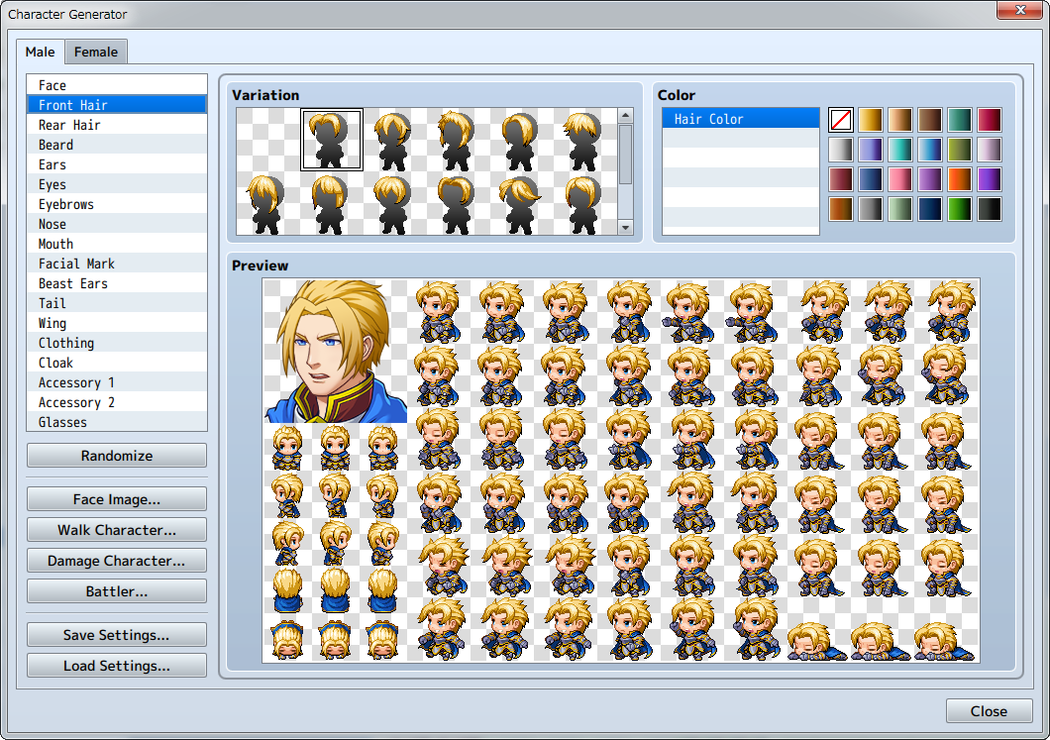

Click on the [Male] or [Female] tabs to change the screen, and choose the variation and color for each feature. Your selection will be displayed in the [Preview] area.

**Randomize**

Sets all the parts at random.

**Face Image**

Opens the export window for face images.

**Walk Character**

Opens the export window for walk characters.

**Damage Character**

Opens the export window for damage characters.

**Battler**

Opens the export window for side-view battlers.

**Save Settings**

Saves the settings of the character created.

**Load Settings**

Loads the saved character settings.

### Export Window

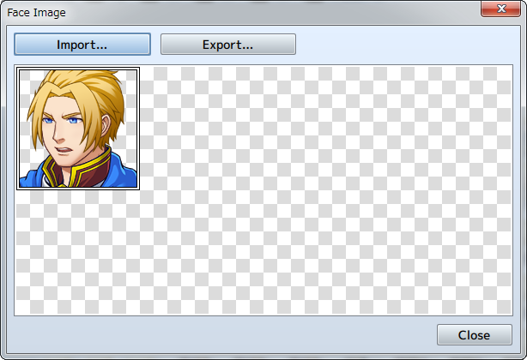

**Import**

Loads a base image from a file and inserts a newly made image.

**Export**

Saves the image to a file.

## Generate Dungeon

Right click the map data text in the Map List and select [Generate Dungeon] to open.

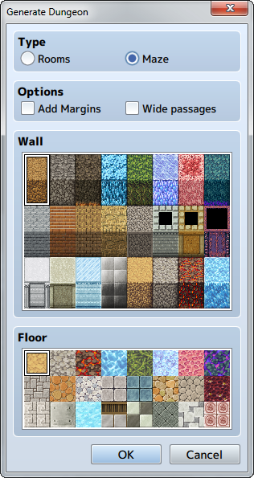

When you select wall and floor tiles, a map will automatically be drawn in maze form. The dungeon will be generated on your selected map, so be sure to increase the map size if you would like to make a large dungeon. If your map size is too small, you will not be able to make a very dungeon-like map.

**Type**

Choose between [Rooms] and [Maze] types. When you select [Rooms], a dungeon with rooms connected by passages will be generated. When you select [Maze], a dungeon with only passages will be generated.

**Options**

**Add Margins**

When selected, margins will be added to the bottom, top, right, and left of the map.

**Wide passages**

When selected, passages will be widened.

**Wall**

Select tiles to be used on walls.  
* Select from the A4 (Wall) tileset being used.

**Floor**

Select tiles to be used on floors.  
* Select from the A5 (Floor) tileset being used.

## Playtest

You can test play your game at any point during creation using the Playtest feature which can be executed by going to [Game] → [Playtest] in the Menu Bar. Using this, you can see whether or not settings and events run as intended upon the release of your game.

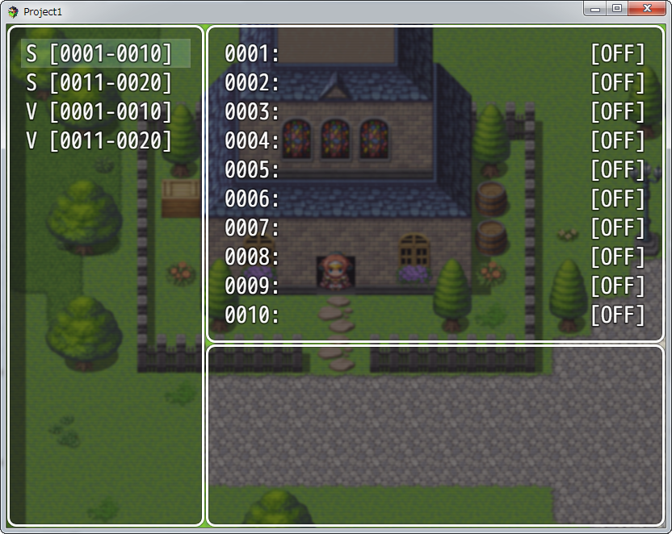

**Using the Debug Feature**

The Debug Screen will be displayed when you press F9 on the keyboard during Playtest. You can change switches and the values of variables currently displayed using this screen.  
* Press [F9] or the cancel button while in the Debug Screen to return to the Playtest.  
  
To change the value of variables, select the target switch/variable (S at the top being the switch, V being the variable, and the number being the range of numbers), then click the action button, and a cursor will appear in the list on the right at the target switch/variable. The ON/OFF values for switches are changed using the action button, and variables are changed using the left and right direction buttons or L/R buttons.

**How to Use Developer Tools**

Press the F8 key during a Playtest to open Developer Tools. Developer Tools have the same function as those built-in to Google Chrome. You can check each element of the game constructed in HTML5.



**Quitting Playtest**

To quit testing your game, press the X button to close the window.

# Playing Your Game

## Basic Controls

### Running Your Game

How you run a game made using this software changes depending on how the game is deployed.

**Using Windows**

Double-click the executable file named [Game.exe] (or [Game]) found in the game data folder.

**Using Mac OS X**

Double-click the executable file named [Game.app] (or [Game]) found in the game data folder.

**On Android/iOS**

View [Converting to an Android App](https://rmmv.neocities.org/page/01_11_05.html) and [Converting to an iOS App](https://rmmv.neocities.org/page/01_11_06.html).

* View [[Local Server Setup](https://rmmv.neocities.org/page/01_11_08.html)] to check your game as a browser game on a local environment.

### Controls

As a standard, controlling games created with this software use a 4-button game pad. Button names are based off the Xbox 360 Controller. Supported game pad buttons/keyboard keys and functions used in standard games are as follows. The D-pad on the gamepad, and arrow keys are used to control the movement of characters and the cursor.

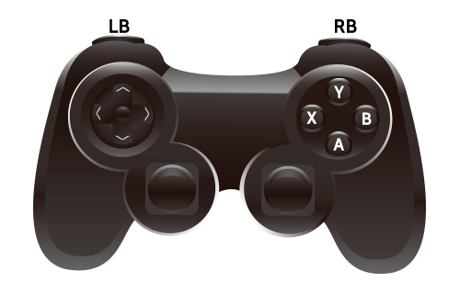

|  |  |  |  |  |
| --- | --- | --- | --- | --- |
| Controls | Game Pad *1 | Keyboard | Mouse | Touch |
| Movement | D-pad | Arrow keys, Num pad | Click destination *2 | Tap destination *2 |
| Action | A | Z, Enter, Space | Click target | Tap target |
| Cancel | B | X, Esc, Num pad 0 | Right click | Tap with two fingers |
| Menu | Y | X, Esc, Num pad 0 | Right click | Tap with two fingers |
| Dash | X | Shift |  |  |
| Previous page | LB | Q, Page up |  |  |
| Next page | RB | W, Page down |  |  |
| Scroll pages | D-pad | Arrow keys, num pad | Drag from inside of page to outside of page/mouse scroll wheel | Tap and hold as you swipe from inside of page to outside of page |

*1 A gamepad with XInput standard support is required on Windows when using a gamepad to control your game.  
Recommended: Xbox 360 Controller for Windows  
  
*2 Continue clicking/tapping and holding inside the screen when you move around the map to continue moving in the direction you click/tap and hold.

### Special Controls

|  |  |
| --- | --- |
| Key | Function |
| F2 | Toggle FPS and Drawing Mode display |
| F3 | Toggle Stretch Mode |
| F4 | Toggle Full Screen Mode |
| F5 | Reload |
| F8 | Open developer tools (Test Play only) |
| F9 | Open Debug Screen (Test Play only) |
| Ctrl + Arrow key | Move through obstacles (Test Play only) |
| Scroll wheel | Scroll pages |

## In-game Menu Controls

### Title Menu

The title screen will appear when you run your game. Select from the below options to run.

**New Game**

Start a new game from the beginning.

**Continue**

Start from a previous save. Select Save Data.

**Options**

Adjust all settings related to the overall game such as BGM volume.

### Menu During Movement

When a player is moving on the map, this menu is displayed when you press the Menu button (same as the Cancel Button except for gamepad). You can do things like use items which recover the state of actors, and save the game state while playing the game using the commands on the upper left. Details for each command are as follows.

**Item**

Check/use items that your party possesses. To use an item, select it from the list (depending on the item, you may need to select the target actor to apply its effect).

**Skill**

Check/use skills (magic, etc.). To use an skill, select it from the list (depending on the skill, you may need to select the target actor to apply its effect).

**Equip**

Check/change equipment. When selecting an actor and changing its equipment, you will select both the equipment you want to change and the equipment you will change (or an empty item to remove the equipment).

**Status**

Check on an actor's status. Select the target Actor.

**Formation**

Change the order of your party members.

**Options**

Adjust all settings related to the overall game such as BGM volume.

**Save**

Save the current game state. Select where you wish to save from 20 different save slots.

**Game End**

Quits the game. Select either [To Title] or [Cancel] (cancel controls).

### Battle Menu

The game will switch to the Battle Screen upon encountering an enemy in the game. You can advance the battle by selecting the following commands. When all party members' HP reaches 0, this will result in a Game Over.

**Party Commands**

Commands that display during each turn. Select [Fight] to continue the battle and [Escape] to run away from the enemy. However, if an enemy moves to attack you, only the enemy can do an action until that turn is over even if you select [Escape].

**Actor Commands**

You will select each party member's action when you select [Fight] in the party commands. The primary actions are [Attack] (attack using the currently equipped weapon), [Guard] (protect oneself and reduce incoming damage) and Item (use currently owned items). The types of actions you can select depend on the actor's settings.

### Shop Menu

At the shop you can buy and sell items, weapons, armor, etc.

**Buy**

When you select [Buy], items, weapons, armors, etc. that you can purchase are displayed. Select the item and item amount and press the OK button to buy.

**Possession/actors able to equip**

The number of selected items possessed is displayed in the right window.  
  
When buying weapons and armor, the party members are displayed and those who are unable to be equipped are grayed out. When you have 5 or more party members, you can use the dash button or click (tap) the right window to display the members beyond the 5th member.

**Sell**

When you select [Sell] and select [Item], [Weapon], [Armor], or [Key Item], the items you possess will be displayed. Select the item you wish to sell, enter the amount to be sold, and press the OK button to sell.

**Entering Amount**

|  |  |
| --- | --- |
| D-pad/arrow key | Function |
| Right | +1 item amount |
| Left | -1 item amount |
| Up | +10 item amount |
| Down | -10 item amount |

* When controlling with a touch device, you can change the amount and confirm your purchase by tapping the below buttons.

|  |  |
| --- | --- |
| Button | Function |
| https://rmmv.neocities.org/inc/img/01_06_img02.png | +1 item amount |
| https://rmmv.neocities.org/inc/img/01_06_img03.png | -1 item amount |
| https://rmmv.neocities.org/inc/img/01_06_img04.png | +10 item amount |
| https://rmmv.neocities.org/inc/img/01_06_img05.png | -10 item amount |
| https://rmmv.neocities.org/inc/img/01_06_img06.png | OK |

### Developer Tools

Developer Tools will be displayed when pressing F8 during Playtest. Please refer to the entry in [[How to Use Developer Tools](https://rmmv.neocities.org/page/01_05.html#p04_01)] for more information.

# Maps

## What are Maps?

Maps are the data that represent the setting for your game. Maps will unfold based on where a character moves on the map when playing the game.  
  
A map's design is edited by placing together parts using for composing your map called "Tiles".

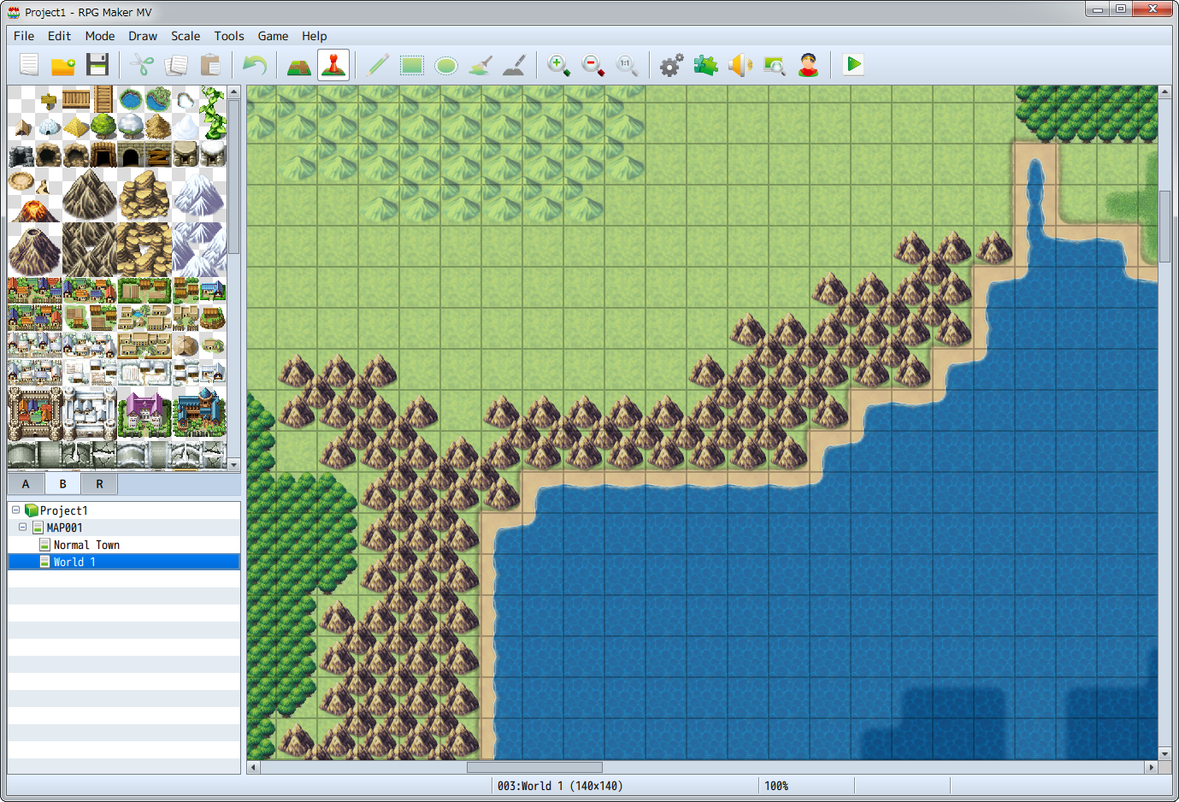

## Map Basic Specifications

### Role of Tiles

Tiles are images which give a map its appearance, and are configured to allow or not allow a character to move across that tile.  
  
In one map, multiple tiles grouped together assigned to be one piece of data are called a "Tileset", which is used as the basis of designing the shape of a map. You can instantly change the appearance of a map by changing the tileset you are using. The contents of a tileset can be edited using the [[Database](https://rmmv.neocities.org/page/01_08_10.html)].

### Tile Classifications

It is possible to include 5 types of tiles for A through E in one tileset. A is the lower layer which represents the terrain and ground, and B through E are upper layer tiles which represent surface elements such as trees and bushes or sign boards.  
  
It is possible to place an upper layer and lower layer tile on the same location on the map. By using this two-layer composition, it is possible to create a very detailed and intricate map.  
  
As a standard, tiles that represent things such as the ocean, grasslands, floors and walls are the lower layer tiles, and upper layer tiles used to decorate those layers are provided.  
Moreover, it is now possible to overlap two types of upper layer tiles allowing for more variation in this version.

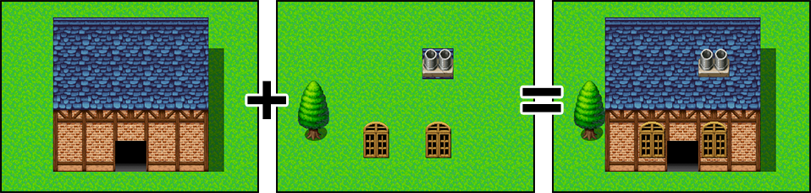

### Map Size and Display Method

The size of a map is measured in tiles, and can be set to have a width and height of 0 to 256 tiles respectively.  
  
The number of tiles visible on a game when playing is 17x13 tiles at one time. For maps larger than this, the area displayed will automatically move centered on the position of the player (scroll processing). Moreover, by connecting the edges of maps, you can have settings where the map loops just as if it was a planet (loop processing).

### Map Positioning

The position of tiles on the map is represented in [Map Coordinates]. The origin of a map is at the upper left corner at (0,0), and moving away from this point X tiles to the right becomes the X coordinate, and moving away from this point Y tiles down becomes the Y coordinate. For example, in a map which has a tile size of 100x100, the coordinates of the bottom right corner is (99,99). The map coordinates of the tile which is currently being edited will appear in the status bar.  
  
Map coordinates can be used in event commands which monitor the current location of your party and the locations where a party moves based on variables.

# Editing Map Designs

## Basic Editing Methods

### Switch to Editing Mode

To edit the design of your map, click the [Map] button on the toolbar (or [Mode] → [Map] in the menu) to switch to Editing Mode.

### Selecting Map Data

Click to select the map data you wish to edit in the Map List found at the bottom left of the window. The design of the map will be displayed in the Map View on the left side.

### Selecting Tiles

Click to select a tile that you will draw from the Tile Palette. The tile that is currently selected will have a white frame around it. Tiles displayed in the Tile Palette will be switched when you click one of the A through E tabs at the bottom.  
  
You can select multiple tiles at once to draw on by drag-selecting them on the Tile Palette.

### Selecting the Drawing Tool and Drawing

You can select tools (the below 5 types) which can be used for drawing tiles by clicking them on the toolbar. Also, tiles will be drawn when you click or drag on the map display area (Map View) on the right side of the window. Each tool can also be selected from the [Draw] Menu.  
  
You can erase tiles that you have drawn by drawing transparent tiles. You can find the transparent tile in the upper left of the upper layer B tab.

** Pencil**

Draws the selected tile in the spot that you have clicked.

** Rectangle**

The selected tile will be drawn in a rectangular area produced by clicking and dragging the cursor diagonally with the beginning of the drag being the starting point and the end of the drag being the ending point.

** Ellipse**

The selected tile will be drawn in a ellipse within a square area produced by clicking and dragging the cursor diagonally with the beginning of the drag being the starting point and the end of the drag being the ending point.

** Flood Fill**

Tiles will be drawn from the location of the tile you click and on all surrounding tiles of the same type that are connected.

** Shadow Pen**

Add or delete shadows for things such as walls in the location you click.

## Other Editing Functions

**Autotile**

A feature called [Autotile] is included in the tiles displayed in the A tab of the Tile Palette. With autotiles, one type of tile contains several patterns, and the border of the tile will be adjusted automatically depending on how the tiles are placed. Tiles which have the autotile function are assigned to [A1] through [A4] in the database [[Tilesets](https://rmmv.neocities.org/page/01_08_10.html)].  
  
Moreover, you can temporarily disable the autotile function by holding [Shift] and drawing tiles or using the eyedropper.

**Autoshadows**

Within autotiles, by placing two or more tiles vertically, a shadow will automatically be drawn to the bottom right of that tile. However, specified tiles will not have shadows drawn on them.

**Shadow Pen**

The Shadow Pen is a tool that allows you to draw shadows for walls and buildings. You can darken the hue by 1/4th of the size of a tile.  
  
Click the [Shadow Pen] button on the toolbar (or go to [Draw] → [Shadow Pen] in the menu), and click on the Map View. A shadow is drawn by clicking on a part which has no shadow, and by clicking a part which already has a shadow, that shadow will be removed.

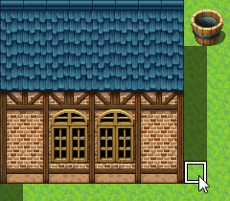

**Upper Layer Tile Special Specifications**

* You can layer 2 different types on the upper maps B-E.  
  * When layering a 3rd tile, the 1st upper tile will disappear.  
  * When the 3rd tile layered is the same as the 2nd tile, the first tile will not disappear.  
  * Only the upper left B tile can erase all upper tiles.
* When a passable tile and an impassable tile are layered, the effect of the tile layered last takes priority.  
  * Even when a passable ☆ tile is on the bottom, the tile with the ☆ will be displayed on top.  
  * When a passable ☆ tile is layered, the impassable tile's effect will take priority.

**Lower Layer Tile Special Specifications**

Amongst the tiles that are displayed in the [A] tab of the Tile Palette, those items found in [A2] in the tileset properties are divided into [Base] (tiles 1 to 4 from the left, or the left half) and [Decoration] tiles (tiles 5 to 8 from the left, or the right half). Decoration tiles can be placed on top of base tiles.  
  
However, for those [Tilesets] which have their [Mode] set to [World Type] in the tileset properties, when placing a decoration tile that is stacked on a 2nd or 4th base tile, the base tile will change either the 1st or 3rd base tile.

# Map Data Controls

Right-clicking Map Data items in the Map List allows you to do things such as configure/change and copy. The functions of each item are as follows.

## Controls via the Context Menu

Right-clicking Map Data items in the Map List allows you to do things such as configure/change and copy. The functions of each item are as follows.

**Edit**

Opens the Settings Window for map data. For more information regarding items that can be configured, please view [[Map Properties](https://rmmv.neocities.org/page/01_07_03.html)].

**New**

Adds new map data. For more information regarding items that can be configured, please view [[Map Properties](https://rmmv.neocities.org/page/01_07_03.html)].

**Load**

New map data is created based on sample data. Click the data name on the list in the window displayed, confirm the details and click [OK].

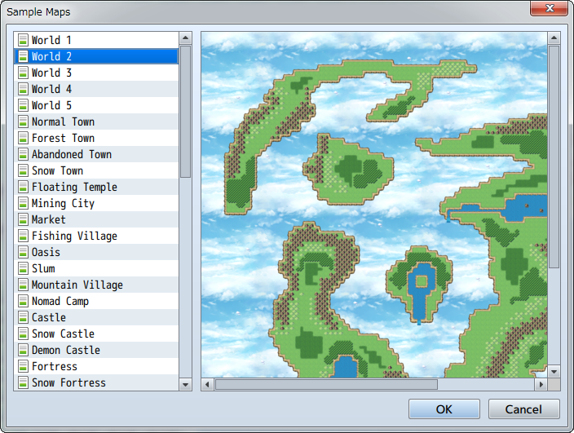

**Copy**

Copies map data to the clipboard.

**Paste**

Adds map data currently in the clipboard.

**Delete**

Deletes map data.

**Shift**

Shifts the placement of all tiles on the map. Specify the shift direction and number of tiles.

**Generate Dungeon**

Automatically generates a maze form map. Please refer to [[How to Use Support Tools](https://rmmv.neocities.org/page/01_05.html#p06)] for more information.

**Save as Image**

Saves the currently selected map in an image format.

## Group Maps

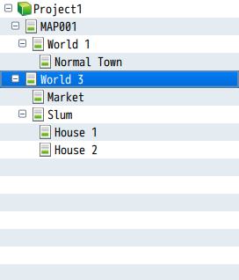

By dragging map data in the Map List onto other map data, the data will appear under the latter map data. Just like grouping the interior map of a building under the map of a town, it is convenient for grouping map data and managing it. By dragging a map which has been moved to the bottom to the folder containing the project name, you can move it to the highest layer.  
  
This hierarchical display only changes the way that things are displayed on the Map List. This will in no way affect the design and settings of the map.

# Map Properties

## Map Details

The Map Properties Window will be displayed when you either create a new map or by right-clicking the map and selecting "Edit". In this window, you can edit things like the size of the map, tools used for designing, background music, conditions for encounters (when a battle starts) with troops and behavior of the game during gameplay.

## Property Details

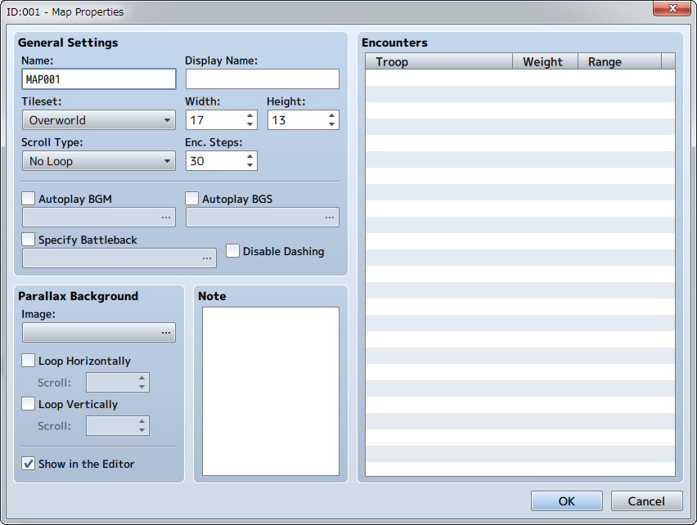

### General Settings

### Name

This is the name of the map. This property is just used in the editor (does not affect the game).

### Display Name

The name of the map that is displayed when the player is moving on the map.

### Tileset

Specify tilesets to be used in the design of the map.

### Width/Height

The size of the map. The [Width] and [Height] can be set from values between 0 and 256 respectively. Parts which extend beyond the map when making it smaller after creation will be deleted.

### Scroll Type

Determines how the map loops. When you set the map to loop, the edge pairs of the map that you designate will allow the player to loop from one edge to the other.

**No Loop**

There will be no looping.

**Loop Vertically**

The upper and lower edges of the map will be connected.

**Loop Horizontally**

The left and right edges of the map will be connected.

**Loop Both**

Both the upper and lower, and the left and right edges of the map will be connected.

### Encounter Steps (Enc. Steps)

Determine the frequency of random encounters by setting the average number of steps a player walks on the map before an encounter occurs (1 to 999/per step equals the movement distance per tile). Set this value low when you want monsters to appear frequently.

### Autoplay BGM/ Autoplay BGS

When enabled, BGM (background music) and BGS (background sounds) will start playing automatically when the player exists on the map. Select the sound files for each that you wish to play.  
When the map and battle BGM is identical, the music will not stop when switching between screens.

### Specify Battleback

When enabled, the background when a battle occurs on this map can be designated using two types of images in combination.  
When not specified, a background that conforms to the terrain will be automatically selected. For other maps, a background which uses a processed image of the map screen will be used.

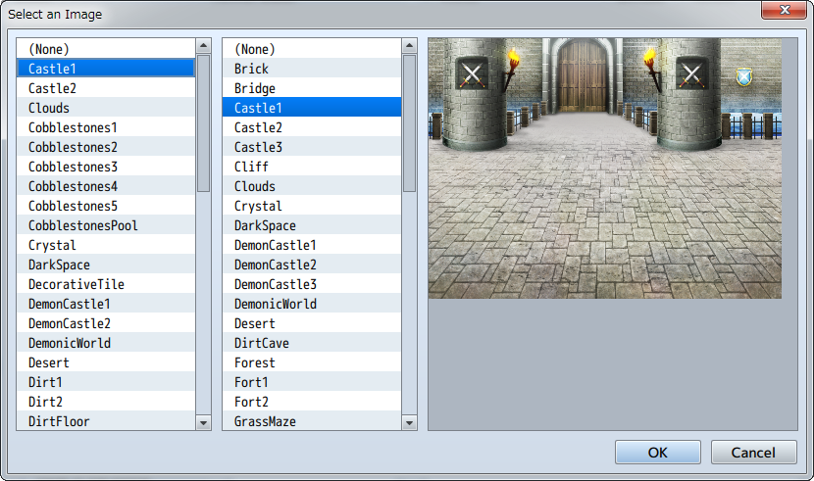

### Disable Dashing

When enabled, a player cannot dash on this map.

### Parallax Background

An image that appears in the transparent part of the map. Select the file you want to use in the window that opens when you click the [...].  
  
When you enable [Loop Vertically] or [Loop Horizontally], the background will scroll according to the movement direction of the player. Also, by setting the scroll to a value other than 0 (-32 to 32), it will automatically scroll. If it's a positive value, it will scroll left or up. If it is a negative number, it will scroll right or down. The higher the absolute value is, the quicker the scroll will be.  
  
When you enable [Show in the Editor], you can confirm the parallax background that you set in the editor. However, there are times when how it is displayed differs in the actual game.  
  
Also, when you add a "!" to the beginning of a parallax background image file name, the parallax will become 0.

### Note

Here you can freely add notes when creating your game. This property is just used in the editor (does not affect the game).

### Encounters

This is the list of enemy troops that appear randomly when the player moves in this map. You can configure the following in the window that opens when you double-click a blank row. When you right-click a troop that you have entered, you can perform actions such as Copy and Delete using the context menu.

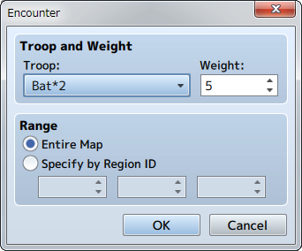

**Troops**

Define the troops you want to configure.

**Weight**

Set the order of priority (0 to 100) that troops appear as battle opponents when encountering enemies. The higher that a troop's weight value is, the higher its encounter will be when there are multiple troops configured.  
  
The encounter rate for troops will be calculated based on a percentage of the total weight of all troops. So for example, let's assume that Troop A's weight is 9, B's is 7 and C's is 4. In this case, Troop A's encounter rate is 9/20 (the total weight being 9+7+4), or 0.45. In other words, it has a 45% chance of appearing. Likewise, Troop B's is 7/20 or 35% and Troop C's is 20%.

**Range**

The range at which this troop is encountered. When setting the troop to be encountered regardless of the region, select "Entire Map". To have an enemy encountered only in a specified region, select "Specify by Region ID" and specify the region ID (up to 3 regions). The way to set the region is as follows.

## Setting the Region

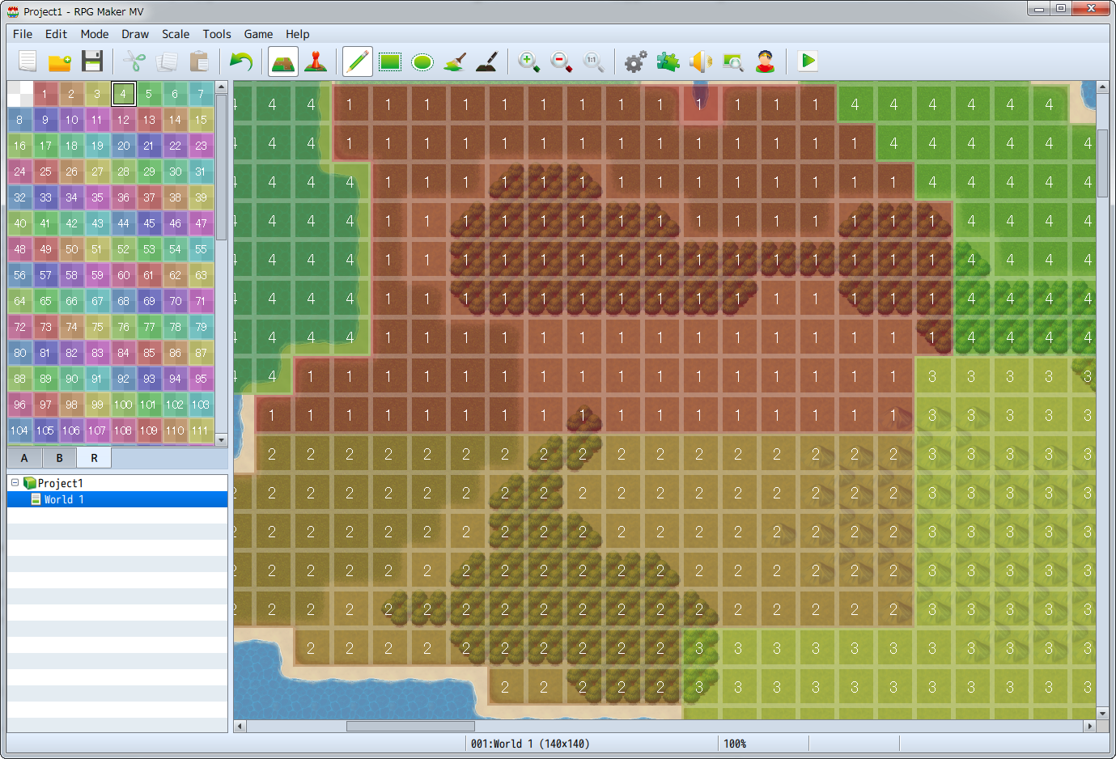

The [Region] that you specify in the Encounter settings of the map indicate the region in which the troop appears. One map can be divided into 255 regions.  
  
To configure region settings, select the R tab for the Tile Palette to switch to Editing Mode. After doing so, click to select the region ID (1 to 255) on the upper left of the window, and by clicking on the Map View, you can configure the region of the tile in that position. Only one region ID can be assigned per tile.

# Database

## What is the Database?

The database is what keeps together all components that make up a game aside from the map and map events. Components such as the character that the player controls, items magic and properties can be prepared as the following 15 types of data.  
  
Data excluding [System], [Types] and [Terms] will be prepared for each type that appears in the game. For example, you will create data for each piece of equipment such as "Health Potions" and "Keys", and configure characteristics such as their names, images and what effects they have when used.

|  |  |
| --- | --- |
| Actors | The character that the player can control. |
| Class | Characteristics that you assign to the actor (traits, growth conditions, etc.). |
| Skills | Actions and special skills (normal attacks, special skills and magic). |
| Item | Items that the player owns (potions, keys, etc.) |
| Weapons | Equipment that actors use for attacking (swords, canes, bows, etc.) |
| Armors | Equipment that an actor uses for defense (armor, shields, accessories, etc.) |
| Enemies | Characters that fight against actors in battle. |
| Troops | Group of enemies that appear in game. |
| States | States for actors, enemies, etc. (Poison, Knockout) |
| Animations | Visual effects that appear during times such as when skills are used. |
| Tileset | Organization of tiles used when creating maps. |
| Common Events | Handles commonly used events. |
| System | Overall game basic settings for things like initial settings and music. |
| Types | Configure Types for elements, skills, weapons, armors and equipment. |
| Terms | Text such as common game commands and parameters. |

## Editing the Database

### Displaying the Edit Screen

Contents of the database are edited in the [Database] window. To display the window, click the [Database] button on the toolbar (or go to [Tools] → [Database]).

### Organization of the Edit Screen

You can select data according to data type using the side menu in the [Database] window. By clicking a button on the side menu and switching the screen, you can create and edit data.  
  
When editing data aside from [System], [Types], and [Terms], first click to select the data that you will edit using the data list on the left side of the window. After doing so, by editing the details of the parameters that are organized on the right side of the window, you can define the characteristics of the data.  
  
By pressing [F4] or [F5] on the keyboard, you can switch between the previous and next data for data selected in the data list.

### Changing the Number of Data Entries

The max number of skills, items, weapons, enemies and troops is set at 2000, and all other types of data are limited to 1000. To change the number of data entries, click the [Change Maximum] button below the data list, and define the new number of data entries. When lowering the maximum number of data entries, data which has a number that exceeds the maxium amount will be deleted.

### Controls via the Context Menu

A menu will appear when right-clicking an item in the data list, allowing you to copy that data. The details for controls related to each item is as follows.

**Copy**

Copy the parameter details of that data to the clipboard.  
When selecting while pressing the Shift key, you can copy multiple data entries.

**Paste**

Apply (overwrite) the parameter details in the clipboard to the data. All data for parameter details of data before performing this action will be lost.

**Clear**

Delete all data parameter details.

### Regarding Data IDs

The numbers which appear at the front of each entry in the data list is its Data ID (unique number). This ID is used on occasions such as specifying data using variables that will be used in event commands.

### Utilizing the Note Field

For some data elements (actors/classes/skills/items/weapons/armors/enemies/states/tilesets), there is a [Note] field available. This is for freely taking notes when creating your game. As a rule, this will not affect the game, there are plugins where you can define additional data using the notes field.

# Actor Settings

## Role of Data

Data which represents the character that the player controls is the actor data.  
You can give each actor unique characteristics.

## Property Details

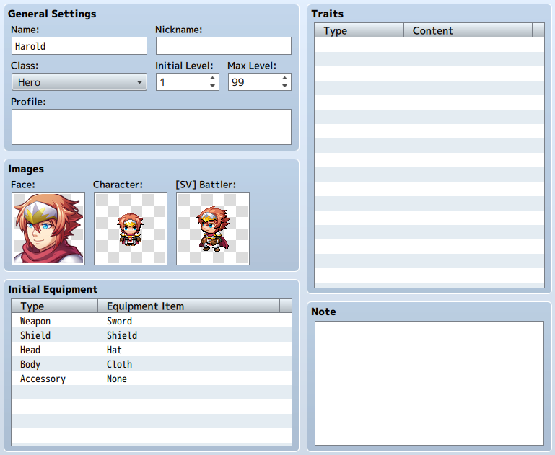

**Name**

[Name] is the name that is displayed during gameplay. There are occasions when the player name will not be fully visible during gameplay and in battle if the name is long.

**Nickname**

The nickname of the actor. This will be displayed on the status screen in the upper right.

**Class**

The class which the actor belongs to. This will affect which skills can be used, which weapons can be equipped, which items can be used, etc. Specific details are edited in the [[Class](https://rmmv.neocities.org/page/01_08_02.html)] tab.

**Initial Level/ Max Level**

[Initial Level] is the level of the actor at the start of game, and [Max Level] is the maximum level an actor can be. An actor will never level up beyond its [Max Level]. Either can be set from 1 to 99.

**Profile**

Introduction of the actor. This will be displayed on the lower portion of the Status Screen.

**Images**

**Face**

Image displayed in the menu.

**Character**

Image displayed on the Map Screen.

**[SV] Battler**

Image displayed in the Battle Screen when in Side-view mode.

**Initial Equipment**

The equipment that an actor starts with at the start of the game. Select the equipment position for each piece from the pull-down list. Equipment which can be selected is limited to what their class is able to equip. Setting this to [None] will cause nothing to be equipped in that location.

**Traits**

The actor's unique traits. Define the details in the window that is displayed when double-clicking each row of the settings field. For more information please refer to [[How to Set Traits](https://rmmv.neocities.org/page/01_08_15.html)].

# Class Settings

## Role of Data

Class data is the collection of traits related to the abilities of actors. Actors must belong to a class, and things such as the way that an actor levels up, how their ability points increase, and the skills they can acquire are determined based on those parameters. It is also possible to give actors unique class traits.Parameters

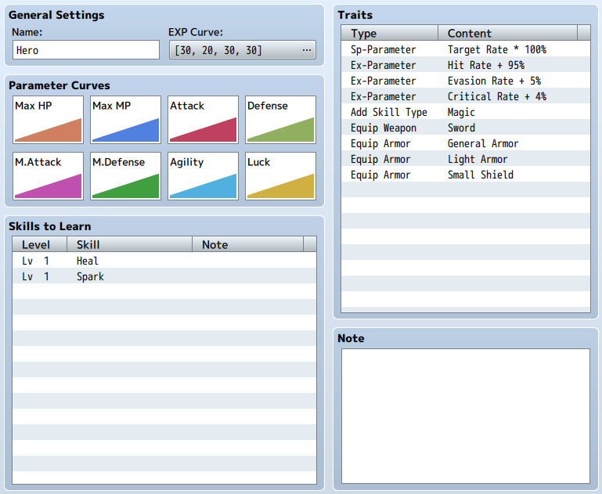

### Name

Name of the Class. The class will be displayed in places such as on the Menu Screen and upper part of the Status List Screen.

### EXP Curve

Parameters for determining the EXP which is required for leveling up. When an actor acquires the needed amount of EXP for each level, that actor's level will increase 1 level and their Skill Points will increase and they will acquire new skills.  
  
The EXP required is set based on the below 4 values in the window that is displayed when you click the [...] in the settings column. The EXP required for each level will be displayed in a list, and a graph will be displayed in the background in the [To Next Level] tab. It's a good idea to refer to this while setting your parameters. The total amount of EXP until reaching each next level can be viewed in the [Total] tab.

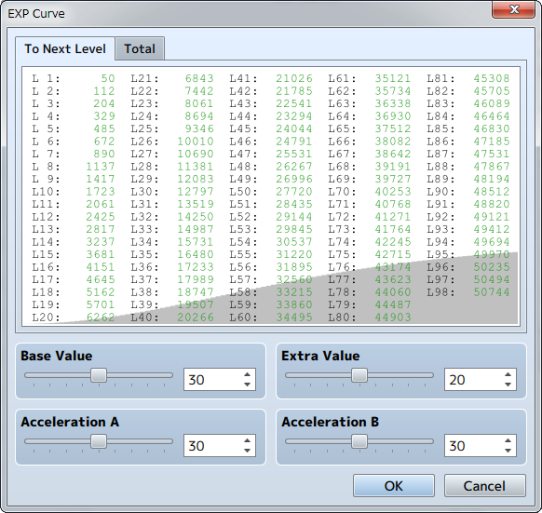

**Base Value**

The standard value for calculating necessary EXP. By lowering this value, the overall necessary EXP will decrease.

**Extra Value**

The designated value added to necessary EXP for each level.

**Acceleration A**

Adjust the rate at which to increase the necessary EXP. By setting this value higher, the amount of necessary EXP will increase proportionately according to the increase in level.

**Acceleration B**

Adjust the rate at which to increase the necessary EXP. By setting this value higher, the rate of increase of necessary EXP will become larger primarily at higher levels.

### Parameter Curves

The parameters for trait values for each level. The Parameter Settings window will open when you double-click a graph. Please refer to the [[Setting Parameter Curves](https://rmmv.neocities.org/page/01_08_02.html#p01)] mentioned later to learn how to set parameters.

### Skills

Skills that an actor gets upon leveling up. Set the levels and skills acquired in the window that is displayed when double-clicking in a column.

### Traits

Traits which you give to actors set to this class. For more information please refer to [[How to Set Traits](https://rmmv.neocities.org/page/01_08_15.html)].

### Note

The [Note] section can be used to make notes while making your game.

## Setting Parameter Curves

In the [Parameter Curves] window, parameter values for each level are set based on the items below. By clicking the tab with the parameter's name, you can switch to the parameter that you want to edit. The value that you specify will be reflected when you click [OK] after you finish editing (changes will be abandoned when you press [Cancel]).

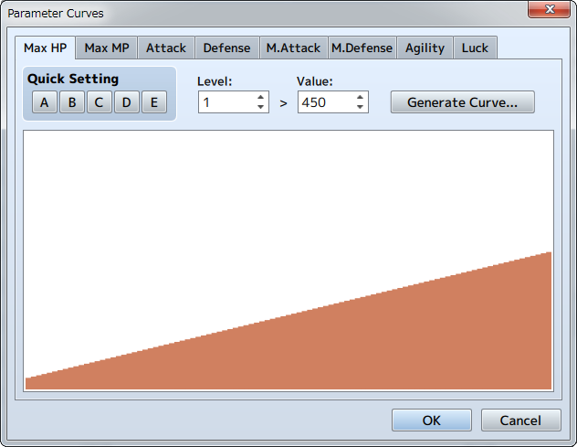

**Quick Settings**

The values set previously will be applied to the parameter values for all levels. There are 5 types of patterns listed [A] through [E], and each pattern will be applied by clicking that pattern's button.

**Level/Value**

Directly edit the parameters for each level. After specifying the level (1 to 99) you wish to edit in the [Level] box, specify the value (Max HP and Max MP can be set from 1 to 9999, all others from 1 to 999) for that level in the [Value] box.

**Generate Curve**

The values of levels will be calculated automatically based on the values at level 1 and level 99.  
  
Define the values (Max HP and Max MP can be set from 1 to 9999, all others from 1 to 999) at [Level 1] and [Level 99] in the window that appears when the [Generate Curve] button is clicked.  
  
Next, decide the Growth Type using the slider. The rate of growth (the amount at which parameter values increase) when set to the left (Fast) will become lower when leveling up, and will become higher when set to the right (Slow). When you click [OK], parameters will be set based on what was specified.

**Graph**

The parameter values for each level will be displayed in a bar graph. By clicking or dragging within the displayed area, you can get the value for parameters for level in the location clicked.

# Skill Settings

## Role of Data

Data that defines the actions an actor takes such as fight or guard during battle as well as magic and special attacks. It is possible to create all kinds of actions by configuring the states when actions can be performed, success, the damage given to the target, etc.

## Parameter Details

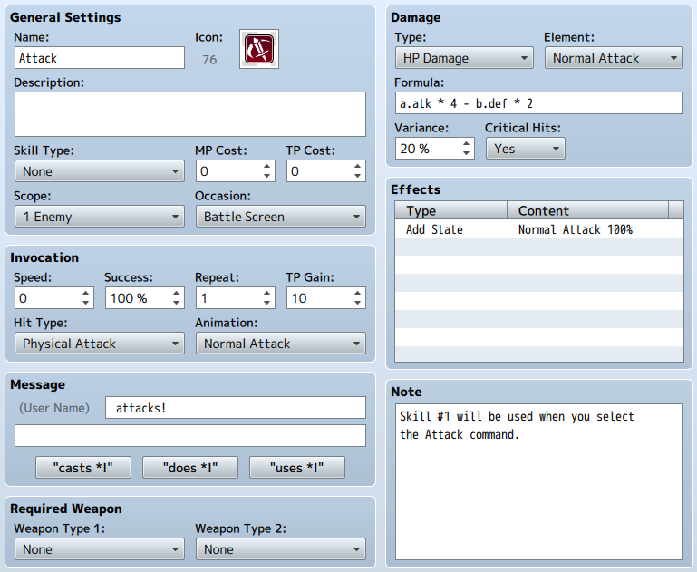

### General Settings

### Name

Name of the skill. If the name of a skill is long, it may not be completely displayed on the Play Screen.

### Icon

Image which appears together with the skill name during gameplay. You can select any image of your choice in the [Select an Image] window that appears after double-clicking on the icon's image. It is typical to select an image that corresponds to characteristics of the skill.

### Description

A description of the skill that appears during gameplay when the cursor is over it.

### Skill Type

Specify the Skill Type. [Magic] and [TP Skills] are setup by default, however you can change this in the [[Terms](https://rmmv.neocities.org/page/01_08_14.html)] settings. For those settings that were configured to something other than [None], the effects of each [Additional Skill Type] can be used only by those actors and classes given the skill.

### MP Cost/TP Cost

The MP (0 to 999) and TP (0 to100) cost when a skill is used. An actor cannot use a skill if they do not have enough MP or TP.

### Scope

The scope of the effect of the skill. You must choose one of the following.

**None**

Those skills that have a scope which does not need to be specified.

**1 Enemy**

One enemy within a group of enemies

**All enemies**

Entire enemy group

**X Random Enemy**

Randomly select number of enemies in a group (X being the number of targets)

**1 Ally**

One ally within a group of allies

**All Allies**

All allies in a group

**1 Ally (Dead)**

A specified ally in a group which is dead

**All Allies (Dead)**

All dead allies in a group

**The User**

The user of the skill

### Occasion

Select the state when a skill can be used. Select one of the following: [Always] (possible to select both in battle and in the Menu Screen), [Battle Screen] (only selectable during battle), [Menu Screen] (only selectable in the Menu Screen) and [Never].

### Invocation

### Speed

The value (between -2000 and 2000) added to an actor's Agility when using a skill. Affects the action order during battle, meaning that they can be effects which are small but can be used quickly, big but take time to use.

### Success

The rate of success (0 to 100%) when using a skill. The effectiveness of the target affects the actual rate of success.

### Repeat

The number of times (1 to 9 times) an effect is applied when used once.

### TP Gain

The amount of TP gained after applying an effect to a target after used successfully.

### Hit Type

Determines the type of hit. You must choose one of the following.

**Certain Hit**

Treats the successful use of a skill as a hit. Counterattacks, Counter Magic and substitutions are ineffective.

**Physical Attack**

Determines the success based on the user's hit rate and the evasion rate of the target. Counterattacks, and substitutions are applicable.

**Magic Attack**

Determines the success based on magic evasion rate of the target. Counter Magic and substitutions are applicable.

### Animations

Animations that appear on the target of the skill used during battle.

### Message

Assign a fixed phrase (up to 2 lines) that appears during battle when a skill is used. The "%1" will be replaced with the name of the skill when used. You can input a fixed phrase by pressing either the [casts *!] button, [does *!] button or the [used *!] button.

### Required Weapon

### Weapon Type 1/Weapon Type 2

The weapon needed as a condition for using a skill. Specify the weapon type in the two lists. If both are set to [None], a skill can be used without any requirements. When selecting two types, a skill can be used when one of either type of weapon is equipped.

### Damage

Specify the formula for the type of effect and the amount of effectiveness if a skill damages a target.

**Type**

Effect types related to HP and MP. Select one open from 6 different types. [Damage] decreases, [Recover] increases, and [Drain] transfers (removes a small amount from target and gives to user).

**Element**

The element that is assigned to an effect.

**Formula**

Formula for determining the effectiveness.  
  
Determine the referenced parameter using the strings below when entering a formula directly. Change "x" to "a" when referring to a value of the attacker, and "b" when referring to a value of the target. Entering "a.atk" refers to the attack power of the attacker. Additionally, you can reference the "n" variable's value by entering "v[n]". You can use the 4 basic arithmetic operator (+, -, *, /) symbols when writing your formula.  
  
When you enter "a.atk * 4 - b.def * 2", the value for the effectiveness of a skill will be calculated as "(Attacker's Attack Power x 4) - (Target's Defense x 2)".  
  
Also, since the effectiveness of a skill can change depending on the element and defense actions, these factors will not be included in the formula.

|  |  |
| --- | --- |
| x.atk | Attack Power |
| x.def | Defense |
| x.mat | Magic Attack |
| x.mdf | Magic Defense |
| x.agi | Agility |
| x.luk | Luck |
| x.mhp | Max HP |
| x.mmp | Max MP |
| x.hp | Current HP |
| x.mp | Current MP |
| x.tp | Current TP |
| x.level | Level |

**Variance**

How much the effectiveness of a skill varies (0 to 100%). Raise or lower the calculated effectiveness within the specified percentage. If the effectiveness is 100 and the variance is 20, the effectiveness will be a value between 80 and 120 (100±20).

**Critical Hits**

Specify whether or not an attack can critical or not by selecting [Yes] or [No]. When selecting [Yes], the chance of landing a critical attack will be determined based on the Critical Chance of the user and the Critical Evasion Rate of the target.

### Effects

Details of effects aside from damage. These can be set in the [Effects] window that appear when double-clicking in the list. For more information, please refer to the [[How to Set Effects](https://rmmv.neocities.org/page/01_08_16.html)] section.

### Note

The [Note] section can be used to make notes while making your game.

# Item Settings

## Role of Data

Item data are those things which represent goods other than equipment. You can add effects that occur when an actor uses an item. Also, you can create items which are needed to progress the story (event contents) such as keys that open doors.Parameter Details

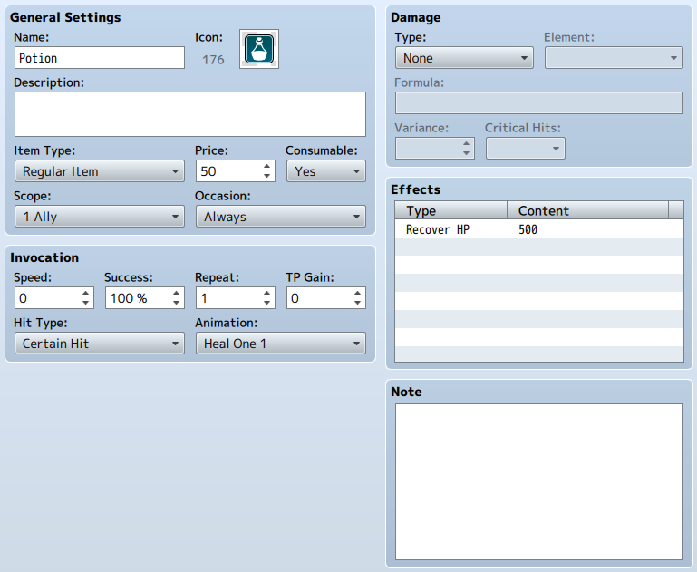

### General Settings

### Name

Name of the item. If the name is long, it may not be completely displayed on the Play Screen.

### Icon

Image which appears together with the item name during gameplay. You can select an image in the [Select an Image] window that appears after double-clicking on the icon's image.

### Description

The description that appears when an item is selected in the Play Screen.

### Item Type

The type of item.

**[Key Item]**

Displayed in a different frame from regular items in the item menu during gameplay.

**[Hidden Item A] and [Hidden Item B]**

These are not displayed on the item screen. These are special items that are only displayed when selecting items during events.

### Price

This is the price of the item when purchasing it in a shop. The price when selling an item will be half of its original price. You can set it so it cannot be sold by setting this value to zero.

### Consumable

This parameter determines whether or not an item disappears after being used. If you set this to [Yes], the quantity of this item will go down by one every time it is used.

### Scope

The scope of the item's effect. You must choose one of the following.

**None**

Those items that have a scope which does not need to be specified

**1 Enemy**

One enemy within a group of enemies

**All enemies**

Entire enemy group

**X Random Enemy**

Randomly select number of enemies in a group (X being the number of targets)

**1 Ally**

One ally within a group of allies

**All Allies**

All allies in a group

**1 Ally (Dead)**

A specified ally in a group which is dead

**All Allies (Dead)**

All dead allies in a group

**The User**

The user of the item

### Occasion

The state in which an item can be used. Select one of the following: [Always] (possible to select both in battle and in the Menu Screen), [Battle Screen] (only selectable during battle), [Menu Screen] (only selectable in the Menu Screen), [Never].

### Invocation

### Speed

The value (between -2000 and 2000) added to an actor's Agility when using an item. Affects the action order during battle, meaning that they can be effects which are small but can be used quickly, big but take time to use.

### Success

The rate of success (0 to 100%) when using an item. The effectiveness of the target affects the actual rate of success.

### Repeat

The number of times (1 to 9 times) an effect is applied when used once.

### TP Gain

The amount of TP gained after applying an effect to a target after used successfully.

### Hit Type

Determines the type of hit.

**Certain Hit**

Treats the successful use of a skill as a hit. Counterattacks, Counter Magic and substitutions are ineffective.

**Physical Attack**

Determines the success based on the user's hit rate and the evasion rate of the target. Counterattacks and substitutions are applicable.

**Magic Attack**

Determines the success based on magic evasion rate of the target. Counter Magic and substitutions are applicable.

### Animations

Animations that appear on the target of the item used during battle.

### Type

Effect types related to HP and MP. Select one open from 6 different types. [Damage] decreases, [Recover] increases, and [Drain] transfers (removes a small amount from target and gives to user).

### Element

The element that is assigned to an effect.

### Damage

Specify the formula for the type of effect and the amount of effectiveness if a skill damages a target.

**Type**

Effect types related to HP and MP. Select one open from 6 different types. [Damage] decreases, [Recover] increases, and [Drain] transfers (removes a small amount from target and gives to user).

**Element**

The element that is assigned to an effect.

**Formula**

Formula for determining the effectiveness.  
  
Determine the referenced parameter using the strings below when entering a formula directly. Change "x" to "a" when referring to a value of the attacker, and "b" when referring to a value of the target. Entering "a.atk" refers to the attack power of the attacker. Additionally, you can reference the "n" variable's value by entering "v[n]". You can use the 4 basic arithmetic operator(+, -, *, /) symbols when writing your formula.  
  
When you enter "a.atk * 4 - b.def * 2", the value for the effectiveness of an item will be calculated as "(Attacker's Attack Power x 4) - (Target's Defense x 2)".  
  
Also, since the effectiveness of an item can change depending on the element and defense actions, these factors will not be included in the formula.

|  |  |
| --- | --- |
| x.atk | Attack Power |
| x.def | Defense |
| x.mat | Magic Attack |
| x.mdf | Magic Defense |
| x.agi | Agility |
| x.luk | Luck |
| x.mhp | Max HP |
| x.mmp | Max MP |
| x.hp | Current HP |
| x.mp | Current MP |
| x.tp | Current TP |
| x.level | Level |

**Variance**

How much the effectiveness of an item varies (0 to 100%). Raise or lower the calculated effectiveness within the specified percentage. If the effectiveness is 100 and the variance is 20, the effectiveness will be a value between 80 and 120 (100±20).

**Critical Hits**

Specify whether or not an attack can critical or not by selecting [Yes] or [No]. When selecting [Yes], the chance of landing a critical attack will be determined based on the Critical Chance of the user and the Critical Evasion Rate of the target.

### Effects

Details of effects aside from damage. These can be set in the [Effects] window that appear when double-clicking in the list. For more information, please refer to the [[How to Set Effects](https://rmmv.neocities.org/page/01_08_16.html)] section.

### Note

The [Note] section can be used to make notes while making your game.

# Weapon/Armor Settings

## Role of Data

Weapons and armor refer to the equipment of an actor. You can do things such as raise or lower specific traits, or give special traits to the actor equipping the item.

## Parameter Details

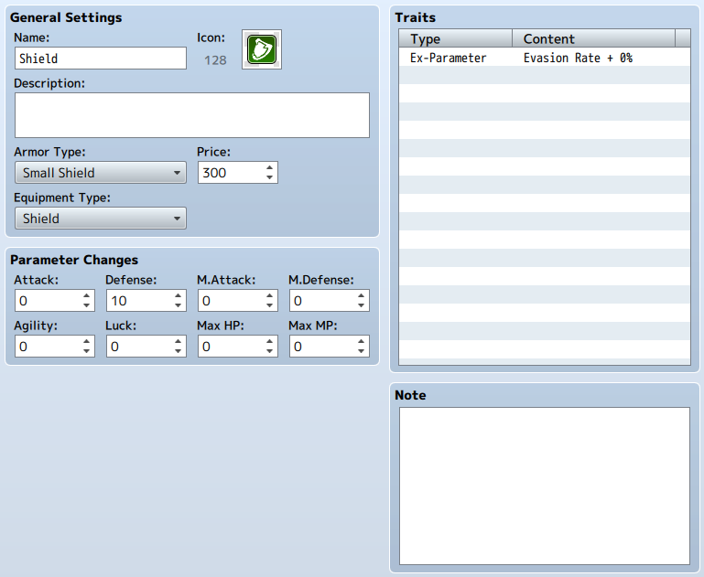

### General Settings

### Name

Name of the weapon/armor. If the name is long, it may not be completely displayed on the Play Screen.

### Icon

The image that is displayed together with the weapon or armor during gameplay. You can select an image in the [Select an Image] window that appears after double-clicking on the icon's image.

### Description

The description that appears when a weapon or armor is selected in the Play Screen.

### Weapon Type/Armor Type

Classification of the weapon or armor. This will be the criterion that determines whether an actor can equip the item using the trait parameters of the actor or class. The weapon/armor classification that you can select can be changed in the [[Terms](https://rmmv.neocities.org/page/01_08_14.html)] settings.

### Price

This is the price when purchasing it in a shop. The price when selling will be half of its original price. You can set it so it cannot be sold by setting this value to zero.

### Animations (Weapons only)

Set the animation when attacking with this weapon.

### Equipment Type (Armor only)

The location where the armor will be equipped (Shield/Head/Body/Accessory). You can equip compatible armor for each location on an actor.

### Parameter Changes

The value added to each trait of an actor when equipped. [Max HP] and [Max MP] can be set from -5000 to 5000, and all others can be set from -500 to 500. By entering a negative value, that trait's value will be decreased.

### Traits

Traits given to the actor when equipping the weapon or armor. You define the details in the window that is displayed when double-clicking each row of the parameter field. For more information please refer to [[How to Set Traits](https://rmmv.neocities.org/page/01_08_15.html)].

### Note

The [Note] section can be used to make notes while making your game.

# Enemy Settings

## Role of Data

Data that represents the enemy characters that the player fights. In addition to having the same trait values as actors, you also need to set the action patterns that enemies will perform during battle.Parameter Details

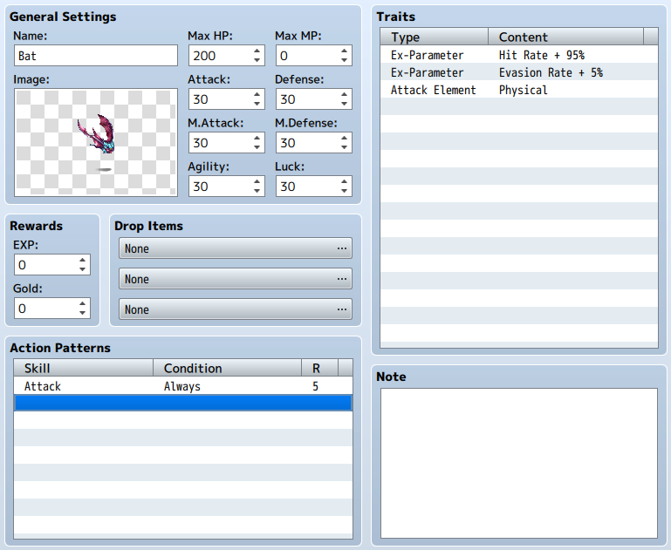

### General Settings

### Name

Name of the enemy. If the name is long, it may not be completely displayed on the Play Screen.

### Image

The image of the enemy that is displayed while playing. You can select an image in the [Select an Image] window that appears after double-clicking on the icon's image. When selecting an image, you can change the hue of the image by moving the [Hue] slider. If the image is set to [None], an image will not be displayed.

### Max HP/Max MP/Attack/Defense/M.Attack/M.Defense/Agility/Luck

The trait values of an enemy when a battle begins. [Max HP] can be set between 1 and 999999, [Max MP] can be set between 0 and 9999, and all others can be set between 1 and 999.

### Rewards

The amount of EXP (1 to 9999999) and Gold (0 to 9999999) that the party receives after winning a battle.

### Drop Items

Items (including weapons and armor) that the party receives after winning a battle. In the window that opens when you double-click inside the field, you can specify the desired item and chance of getting that item by setting the [Probability] (1/1 to 1/1000).

### Action Patterns

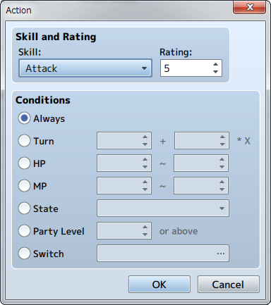

**Turn**

The number of turns that have passed will be used as a condition. Turns will be defined using [A + B * X] with A being the number of turns from the start of battle, and B being the interval of turns. If you set A to 2, and B to 3, conditions will be met every 3 turns from the 2nd turn (5th turn, 8th turn...).

**HP**

The HP of the enemy will be used as a condition. Specify the range of the percentage of Max HP (0 to 100%). The condition will be met when the enemy's HP is within the specified range.

**MP**

The MP of the enemy will be used as a condition. Specify the range of the percentage of Max MP (0 to 100%). The condition will be met when the enemy's MP is within the specified range.

**State**

When the character is in the specified state will be used as a condition.

**Party Level**

The level of the party members will be used as a condition. The condition will be met when the level of the party member with the highest level is equal to or above the specified value.

**Switch**

The specified switch will be used as a condition. The condition will be met when this switch is on.

### Traits

Traits of the enemy. You define the details in the window that is displayed when double-clicking each row of the settings field. For more information please refer to [[How to Set Traits](https://rmmv.neocities.org/page/01_08_15.html)].

### Note

The [Note] section can be used to make notes while making your game.

## Application Rules for Action Patterns

Amongst the actions set in [Action Patterns], the actions which will be performed during battle will be decided according to the following rules.

1. Those actions which fulfill the conditions will be picked out from the configured actions. No action will occur if there is no action that meets the required condition.
2. Within those actions that meet the conditions, the action with the highest rating and the action with a rating that is within two points of the highest rating will be treated as possible choices.
3. Amongst those possible choices, those actions which have a rating difference of 1 and 2 from the highest rating will have their chance of being chosen being 2/3 and 1/3 of the highest rating. The chance of being chosen will be the same for multiple actions which have the same rating.

**Example 1: The action rating is [5] and [5]**

The chance for each becomes 50%.

**Example 2: The action rating is [6],[5],[4],[3]**

[6] will be 50%, [5] will be 33.3% (2/3 of 50%), [4] will be 16.6% (1/3 of 50%). [3] will not be a choice.

**Example 3: The action rating is [5],[3] and [3]**

[5] is 60%, each [3] is 20% (1/3 of 60%).

1. The action used will be determined using random numbers based on the usage probability of those actions which are candidates.

# Troop Settings

## Role of Data

Troops are the data for the groups of enemies that appear during gameplay. The enemies that you have the player fight with through moving in the map and command events are specified based on this data. Even when having the player fight against just one enemy, you must prepare data for the troop with that enemy. "Battle Events" (events during battle) will also be set for each troop.

## Parameter Details

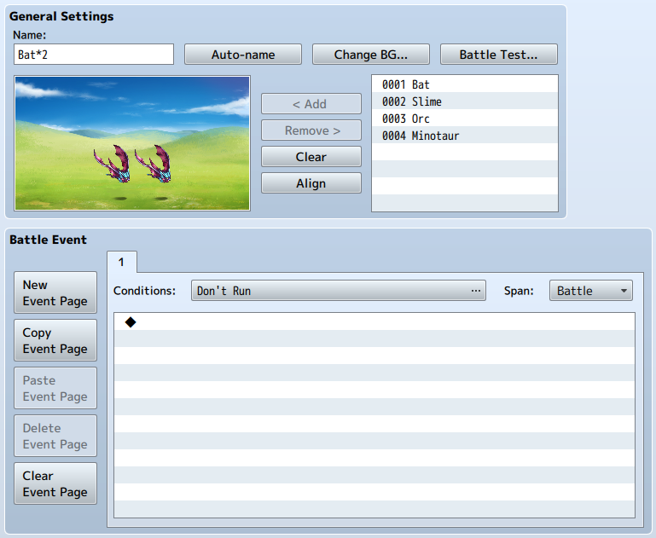

### General Settings

### Name

The name of the troop. This property is just used in the editor (does not affect the game). By clicking the [Auto-name] button, a name will be automatically generated based on the characters entered.

### Change BG

Change the battle background that will be displayed in the Placement View. Specify the background using the left field, and the image used for the ground in the right field respectively in the window that is displayed. These settings are only used inside the editor (does not affect the game), and other data will be shared and used also when editing.

### Battle Test

Run a battle test with the troop. Specify the actors that will battle, equipment, and levels using the tabs labeled [1] through [4] in the window that is displayed (trait values based on the settings will be displayed in the [Status] section). A window will open and a battle will start when you click [OK]. The test will end when the window is closed.  
* Save edited data when a plugin is set. When not saved, the plugin settings will not be reflected in the battle test.

### Placement View

Those enemies that belong to the troop. It is possible to register up to 8 enemies (including those of the same type) in a single group.  
  
By dragging on an enemy in the Placement View, you can move the enemy. Additionally, when you right-click on an enemy in the Placement View and select [Appear Halfway], the enemy will become an enemy that will not appear until running an [Enemy Appearance] Event Command in the Battle Events.  
  
Use the buttons below to edit contents of the troop.

**Add**

Add the enemy selected in the field on the right to the Placement View. You can also add by double-clicking an enemy in the list. The order in which the enemies were added will be reflected in the enemy list displayed during battle.

**Remove**

Remove the enemy selected in the Placement View.

**Clear**

Delete all enemies in the Placement View.

**Align**

Align the positions of the enemies in the Placement View according to the order which they were entered from the left.

## Battle Event Parameters

Configure event conditions executed during battle with enemies and their details in the [Battle Event] section. Just like map events, it is possible to divide the contents processed depending on the situation using the Event Page and appear conditions.

### Event Page Controls

You can control Event Pages using the [New Event Page], [Copy Event Page], [Paste Event page] and [Clear Event Page] buttons located on the left. The functions are the same as the map events.

### Conditions

Conditions for the event pages. In the [Conditions] window that appears when the [...] button is pressed, enable the conditions from the below 5 conditions, and configure the decision criterion used for each. Unlike map events, if you do not specify any conditions for the battle events, the event page will not be run. Also, if there are multiple event pages that fulfill conditions, the event page with the smallest number will be the one which is used.

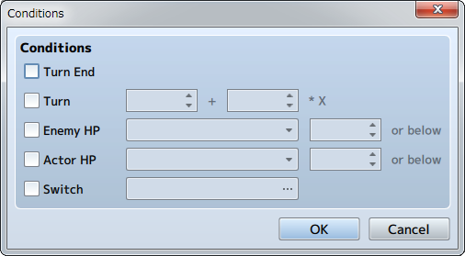

**Turn End**

The moment a turn ends will be treated as a condition.

**Turn**

When the number of turns specified have passed from the start of battle will be treated as a condition. Specify the number of turns from the start of battle in the field on the left and the interval between turns on the right.

**Enemy HP**

When an enemy's HP falls below the specified amount, it will be treated as a condition. Specify the enemy and the value (percentage of Max HP).

**Actor HP**

Treats when an actor's HP falls below the specified value. Specify the actor and the value (percentage of Max HP).

**Switch**

When the specified switch is set to ON will be treated as a condition.

### Span

Specify the timing of when the contents of the event page are allowed to run.

**Battle**

The event will run when a condition is first met from the start of battle. Once it has been run once, it will not be run again.

**Turn**

Conditions will be checked each turn, and the event will be run if there is a condition met.

**Moment**

The event will be run repeatedly while a condition is met. If event pages are not controlled with switches, there are cases where a battle will not progress, so please keep that in mind.

### Run Contents

Running an event when [Conditions] and [Span] are met will be configured based on event commands. Editing is done the same way as the [[Contents](https://rmmv.neocities.org/page/01_09_03.html#p03)] for map events.

# State Settings

## Role of Data

States are things like "Poison" and "Confusion", those abnormal states which affect the condition and actions of a character. Configure the specific effects in the data when a state is added. You can prepare not only states with negative effects such as [Poison], [HP decreased], but also states with positive effects such as [Enraged], [Attack Power Increased].  
  
Moreover, State #1, named [Knockout], is a special state that is automatically applied to characters and enemies when their HP reaches zero. If all members of a party are in this state, it will result in a game over.

## Parameter Details

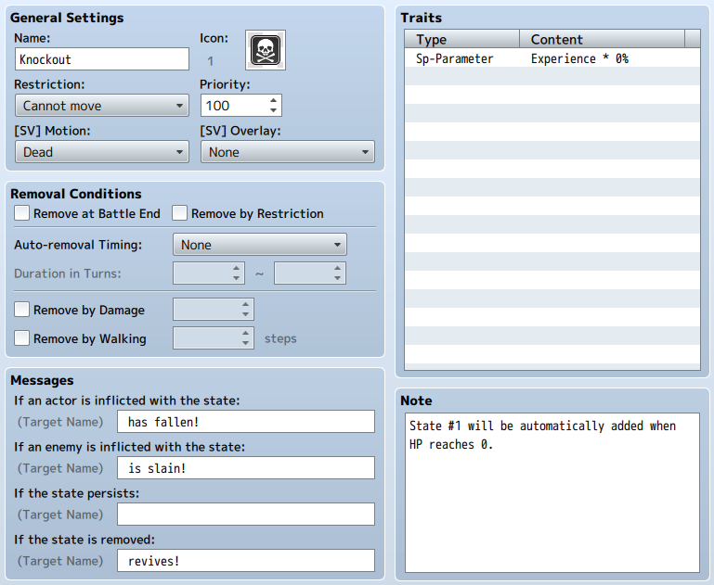

### General Settings

### Name

The name of the state. States are displayed using icons so the name will never be used during gameplay.

### Icon

This icon is the image displayed next to an actor's name or above an enemy's head when in that state. You can select an image in the [Select an Image] window that appears after double-clicking on the icon's image. Try choosing an icon that makes the details of the state clear.

### Restriction

Restricts the actions of characters in a state. The details of a restriction will be set based on the 5 items below. If there are multiple restrictions configured for a state, the restriction at the bottom will be prioritized.

**None**

Actions will not be restricted.

**Attack an Enemy**

Will definitely attack an enemy.

**Attack Anyone**

Will definitely attack either an enemy or ally.

**Attack an Ally**

Will definitely attack an ally.

**Cannot Move**

Cannot move at all.

### Priority

Priority (0 to 100) of displaying state icons. The icon with the highest priority will be displayed if a character has multiple states. If the priorities are the same, the state with the youngest ID will be prioritized.

### [SV] Motion

Set the motion that will be displayed in Side Menu Mode when a state is active.

### [SV] Overlay

Set the overlay image that will be displayed in Side Menu Mode when a state is active.

### Removal Conditions

Conditions to remove a state. Conditions will be set based on the items below. If there are multiple conditions configured, the requirements for each will be determined and the condition removed.

**Remove at Battle End**

When enabled, the condition will be removed when the battle ends.

**Remove by Restriction**

When enabled, the condition will be removed when another state is added that has separate restrictions.

**Auto-removal Timing/Duration in Turns**

Removed after turn. When using [Action End], the condition will be removed after the active character finishes an action, and will be removed after a turn ends and before returning to Action Selection when using [Turn End]. Specify the lower limit and upper limit (0 to 9999) of number of turns until a condition is removed following being given a state using [Duration in Turns].

**Remove by Damage**

A condition will have a specified chance (0 to 100%) of being removed when receiving any sort of damage.

**Remove by Walking**

A condition will be removed when the player moves on the map after walking over the number of tiles specified (0 to 9999).

### Message

Message that gets displayed during battle when this state is given or removed. For each of the following 4 states, a message will be displayed following the target's name: "If an actor is inflicted with the state","If an enemy is inflicted with the state","If the state persists", and "If the state is removed".

### Traits

Traits given to the target when given a state. For more information please refer to [[How to Set Traits](https://rmmv.neocities.org/page/01_08_15.html)].

### Note

The [Note] section can be used to make notes while making your game.

# Animation Settings

## Role of Data

Animations are the data that can be played for visual representations for when enemies attack in the Battle Screen and things on the Map Screen. These are created by placing image patterns (cells) in a "Frame".

## Parameter Details

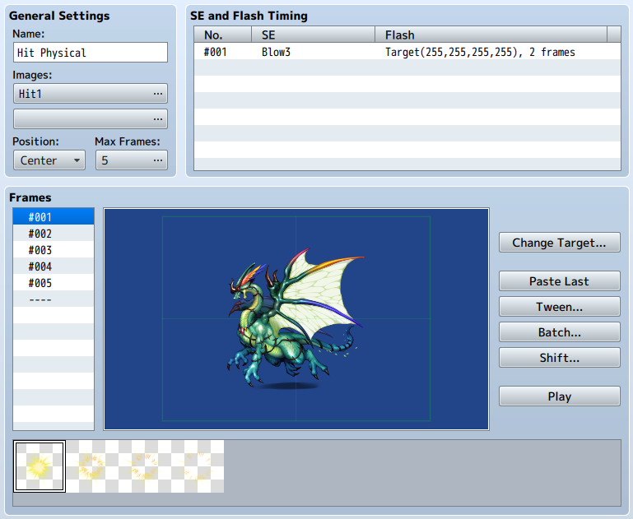

### General Settings

### Name

The name of the animation. This property is just used in the editor (does not affect the game).

### Images

Image files used for creating animations (up to two images). Specify the file you want to use in the [Select an Image] window that is displayed when you press either button. When doing so, you can change the hue of the image by adjusting the [Hue] slider and use the adjusted image. The pattern image will be displayed in the [Pattern Palette] when you specify a file.

### Position

Specify the position where the animation will be displayed. By selecting [Head], [Center] or [Feet], the top, center, and bottom of each character will be used. The animation will be displayed on the entire screen if this is set to [Screen]. Moreover, this animation when set to a skill or item that has an effect that affects multiple characters, it will be displayed for each character when the animation's position is set to [Head], [Center] or [Feet].

### Max Frames

The overall frame count (1 to 200) for an animation. Specify this number in the window that appears when pressing the button. The number specified here will appear in the frame list. When you lower the frame count, those frames whose numbers exceed that amount will be deleted.

### SE and Flash Timing

Sets the timing of when to play the sound effect and the screen flash during the animation. In the [SE and Flash Timing] window that is displayed when you double-click any row (a blank row when creating a new entry) in the list, you can specify the contents below.  
  
A menu will appear if you right-click an item in the list where you can perform actions such as [Edit], [Cut], [Copy] and [Delete].

**Frames**

Specify the frame number where the sound effect and flash will be played.

**SE**

Specify the sound effect that will play.

**Flash**

Specify details for when the flash is played. Select [Target] to make a character flash, [Screen] to make the entire screen flash. You can specify the color of the flash by adjusting the [Red], [Green] and [Blue] values, and its intensity by increasing and decreasing its [Strength] (between 0 and 255). [Duration] is set to play for the number of frames (1 to 200). [Hide Target] causes the character to disappear temporarily, and you use this when you want to hide the character during the animation.

### Frames

### Frame List

List of frames in the animation. The frame number that you click becomes the frame that you will edit, and its contents will be displayed in the Frame View. By clicking the [Back] and [Next] buttons at the top and bottom of the list, you can change to the previous or next frame to edit. Additionally, using the menu that is displayed when right-clicking the frame number, you can [Copy], [Paste], [Clear], [Insert] and Delete frames.

### Frame View

Contents of the frame. Set what is displayed by placing the images in the Pattern Palette as [Cells]. The green rectangle is the area that is displayed in the game window.  
  
Please view [Controlling the Frame View] mentioned later to learn how to edit.

### Change Target

Change the image of the enemy displayed in the Frame View. This property is just used in the editor (does not affect the game).

### Paste Last

Changes the currently selected frame to be the same as the previous one.

### Tween

Frame cells will be automatically created based on the two frames that were specified. Enter in the range for the frames and cells to be tweened, and check the items to tween using the boxes available and click [OK]. For example, by placing the cell in frame 1 to the left side, and placing it on the right in frame 10 and tweening the position between frames 1 and 10, the cells in frames 2 to 9 will be automatically animated to appear to be moving from left to right.

### Batch

Set the cells to be the same in the specified frame range. Specify the frame and cell range in the [Frame] and [Cell] fields, select the items to be set and select the values for each item.

### Shift

Shift the position of multiple cells placed in the specified frame.

### Play

The animation which you are currently making will be played when pressing the Play button.

### Pattern Palette

Displays the pattern images contained the file that was specified in the [Images] section. When clicked, the pattern will be the one to be placed in the frame. Treating the pattern in the upper left of the palette as #1, numbers (pattern number) for the other patterns will be assigned in order from left to right.

## Controlling the Frame View

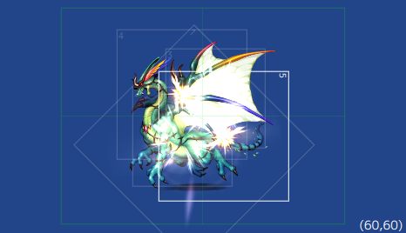

### Placing Cells

Choose the image to be placed in the frame using the [Pattern Palette], and double click an empty spot in the Frame Edit Area. After doing so, that image will be placed in the prepared cell. It is possible to place up to 16 cells in 1 frame.

### Display

The frame and number will be displayed in the cell. A white frame means that the cell is currently selected. The number is the priority order of the cell, and larger cells will be displayed towards the front.

### Selecting a Cell to Edit

Clicking a cell will cause its frame to become white and will be selected to be edited. Smaller cells with the same number as other cells can be selected by clicking them while holding the [Shift] key.

### Moving Cells

Drag cells to move them. The position of cells currently selected will be displayed as coordinates in the bottom right of the Frame Edit Area. Assuming the coordinates in the center of the image are (0,0), X coordinates are displayed using values (-408 to 408) and Y coordinates are displayed using values (-312 to 312).

### Controls via the Context Menu

By right-clicking a cell, a menu will be displayed where you can perform the following actions. You can open the [Cell Settings] window by also double-clicking.

### ▼Context Menu Items

**New**

Place a new cell.

**Edit**

Open the Cell Settings window.

**Cut**

Copy the currently selected cell to the clipboard and delete it.

**Copy**

Copy the currently selected cell to the clipboard.

**Paste**

Place the cell currently in the clipboard.

**Delete**

Delete the currently selected cell.

**Undo**

Cancel the most previous action, and return to the previous state prior to performing the action. It is possible to undo up to 20 actions.

**Redo**

Return the state back to what it was before pressing Undo.

**To Upper/To Lower**

Change the priority of displaying the cells (front/back).

### ▼Cell Setting Window Contents

**Pattern**

The pattern number. Changing the number will change it to the corresponding cell.

**X/Y**

Display position of the cell. X coordinates can be set from -408 to 408, and Y coordinates can be set from -312 to 312.

**Scale**

Changes the display magnification of the cell. The scale of the cell can be changed from 20 to 800% with the original image being 100%.

**Rotation**

The rotation (1 to 360 degrees) of the cell when displayed. Cells will be rotated clockwise using the specified degree of rotation.

**Mirror**

Setting this to [Yes] will flip the display of the cell's pattern.

**Opacity**

The opacity (0 to 255) of the cell. The smaller the value, the more opaque the cell will be, and will not be visible when set to 0.

**Blend**

Allows you to blend the hue of two cells that overlap. [Normal] will have it be displayed normally, and [Additive] will cause it to be whiter.

# Tileset Settings

## Role of Data

Tilesets are the collection of "Tiles" used to design your map. Create tiles by setting whether a character can walk on the image used for the tile, and also the behavior in the game.  
  
Original images created for the map can be used as well by creating tilesets which use those images, and assign as map data.  
  
Moreover, whether or not vehicles (boats/large ships) can go over tiles is determined by the position over the tileset. For more information, please view [Asset Standards](https://rmmv.neocities.org/page/01_11_01.html).  
Planes are able to travel over all tiles. However, there are only able to land on tiles which can be walked on.

## Parameter Details

### General Settings

### Name

A tileset's name. This property is just used in the editor (does not affect the game).

### Mode

The purpose of the tileset. This primarily influences the treatment of [special specifications of lower tiles](https://rmmv.neocities.org/page/01_07_01.html#p01) and [battlebacks](https://rmmv.neocities.org/page/01_07_03.html" \l "p01).  
Basically, choose [Field Type] for tiles which represent the overworld like the ocean and land, and [Area Type] for all other situations.

### Images

Settings for images used for tiles. Specify the file you want to use for each type (Sets A through E) in the [Select an Image] window that is displayed when you press the button for each type. An image's contents will be displayed in the [Tile List] on the right.

### Tile List

The image used for a tileset in [Images] will be displayed. You can switch the images displayed by clicking tabs [A] through [E] at the bottom. The tiles for the images specified in [A1] through [A5] in the [Images] section will be displayed in order.  
  
Marks representing the parameter values in the current settings editing mode will be displayed on top of each tile. You can change these parameter values by clicking the tile.

### Passage

Switch to the editing mode where you can set whether a tile can be entered or not. Tiles marked with a [○] can be entered, ones marked with an [×] cannot be entered. Those which have a [☆] can also be entered, however this is for when hiding characters behind buildings (only possible in all other tabs except [A]).

### Passage (4 dir)

Switch to the editing mode where you can set the direction from where tile can be entered. Use [Passage: Block] when creating tiles that can be passed only from a defined direction. For example, when you set the edge of a tile that represents a cliff as impassable, characters will be unable to move between that tile and the next tile, creating the sense of height.  
  
Those tiles with marks displayed as arrows pointing in a specific indicate that it is possible to move from that direction, ones without arrows are not passable. Moreover, by changing the parameters of the [Passage] setting, these settings will change automatically.

### Ladder

Switch to the editing mode for ladder settings. When you add this parameter, the direction a character using this tile faces will be fixed to up, giving the appearance of going up and down things like ladders and ropes.  
  
Click the marks in the Tile List to change tiles to have this parameter or not. A mark (a ladder) will be displayed on tiles which have this setting.

### Bush

Switch to the editing mode for bush settings. When a tile has this setting, 12 pixels from the bottom of characters who cross this tile will appear half transparent, as if their feet are being hidden by dense grass.  
  
However, part of the tile will not become half transparent depending on the image when giving this setting to tiles in [A1] through [A4].  
  
Click the marks in the Tile List to change tiles to have this parameter or not. A mark (two wavy lines) will be displayed on tiles which have this setting.

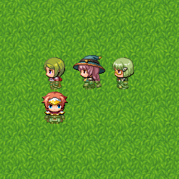

### Counter

Switch to the editing mode for counter settings. When a tile is given this setting, it will start events even when a character and event are not right next to each other, just as when talking to a character with a desk between them.  
  
Also, setting this to the tile in [A2], tiles having this element will be drawn 12 pixels downward.  
  
Click the marks in the Tile List to change tiles to have this parameter or not. Tiles which have this setting have a mark (4-sided diamond) displayed on them.

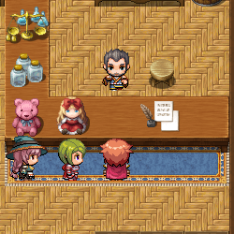

### Damage Floor

Switch to the editing mode for Damage Floors. When a tile is given this setting, characters will receive damage when crossing this tile. This can be used for representing dangerous terrain like poisonous swamps, trees with thorns.  
  
Click the marks in the Tile List to change tiles to have this parameter or not. A mark (two triangles) will be displayed on tiles which have this setting.

### Terrain Tag

You can assign values between 0 and 7 to each tile. No specific uses are defined. This value can be retrieved by using the [Get Location Info] event command. Those terrain tags retrieved which are located in upper layers other than zero will be prioritized.

### Note

The [Note] section can be used to make notes while making your game.